**Cloud Computing and Vocabulary**

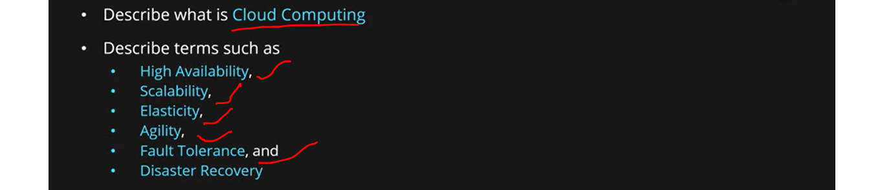

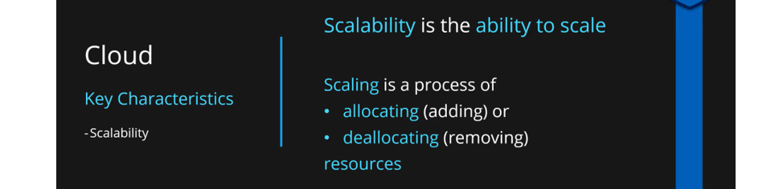

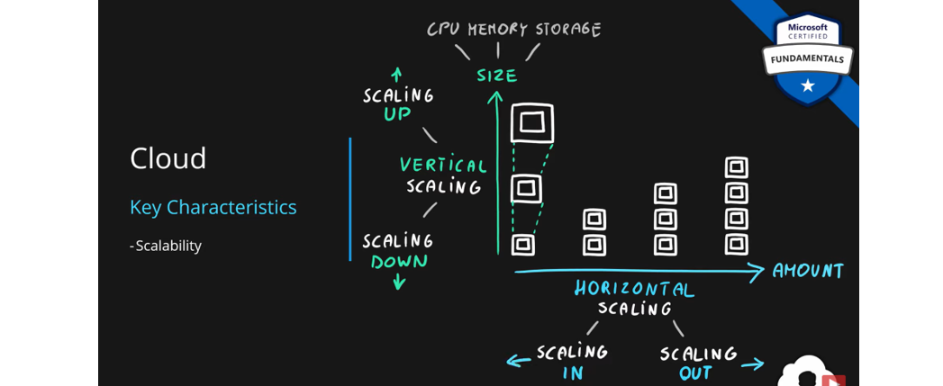

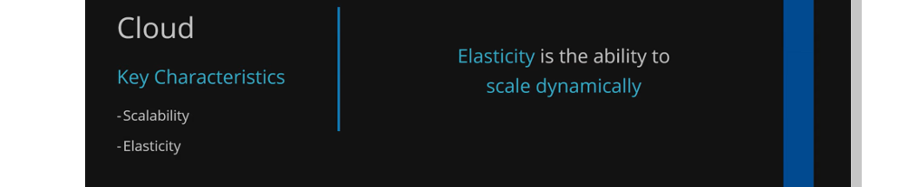

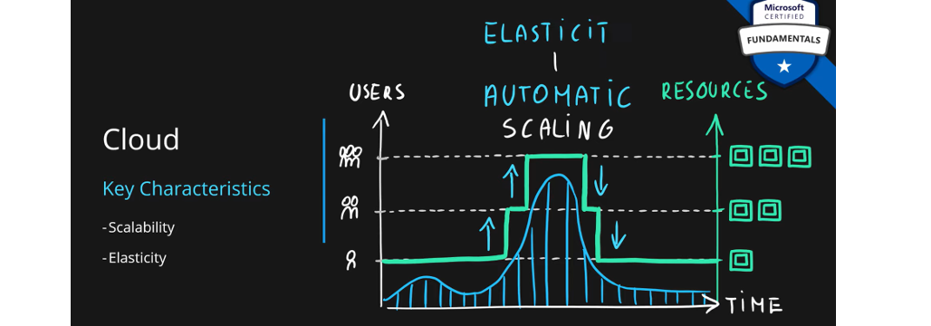

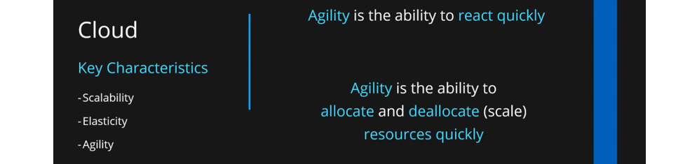

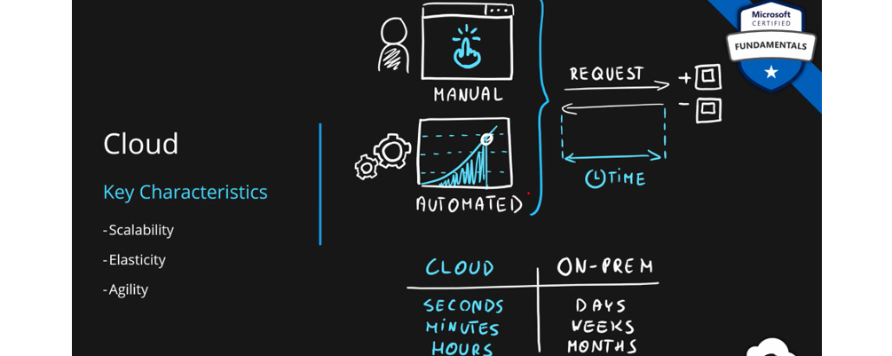



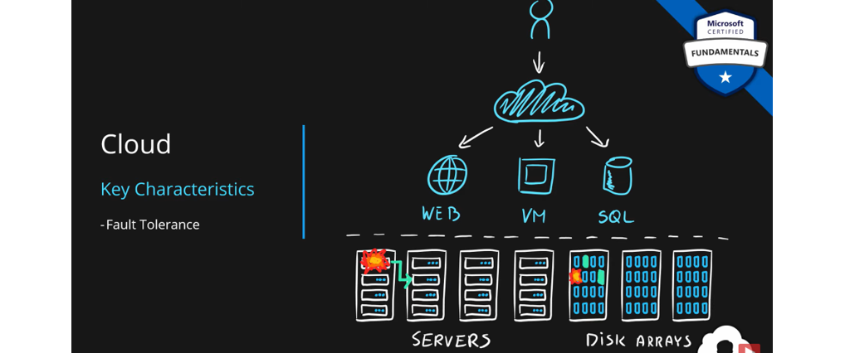

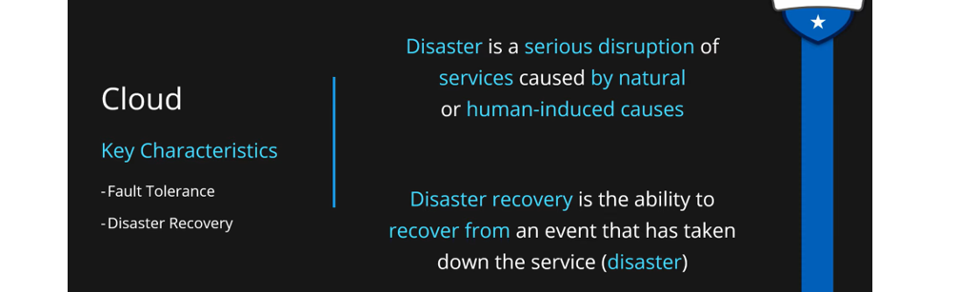

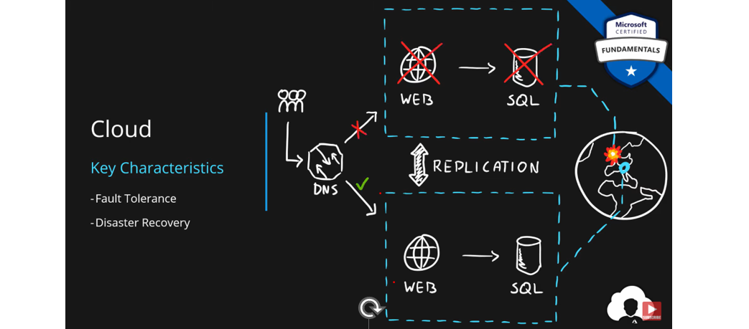

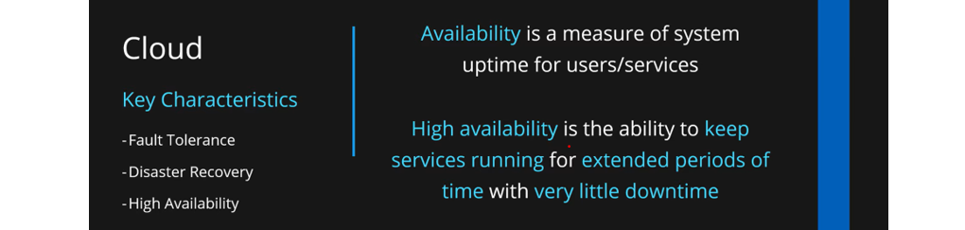

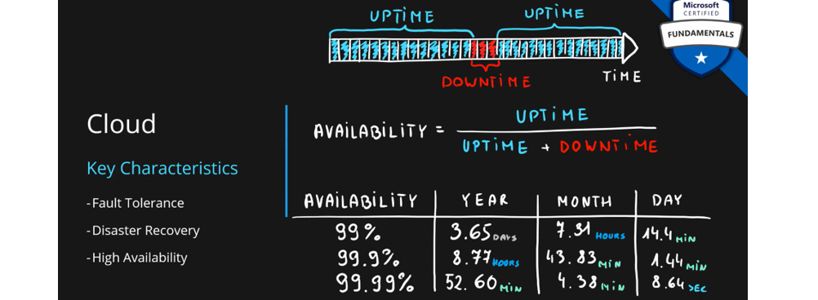

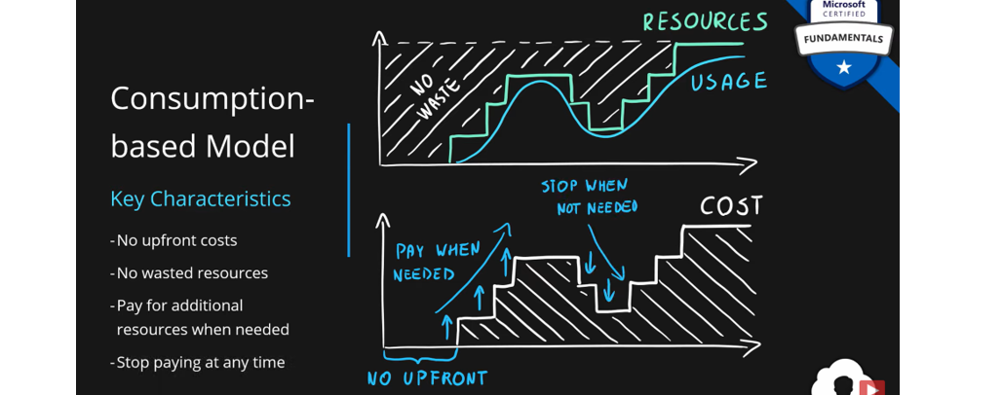

**Cloud Service Models (IaaS vs PaaS vs SaaS cloud service models)**



**Azure Logic App**

when it comes to integration across multiple services in Azure, there's actually no better service than Azure Logic Apps.

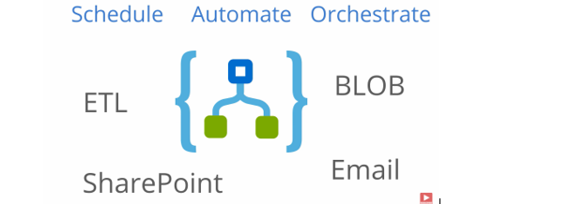

Azure Logic App is a cloud service that helps you to schedule, automate and orchestrate tasks, business processes, and workflows when you need to integrate apps, data, systems and services across enterprises or organizations. What this really means is that you are creating a flow that represent your business flows.

First of all, you always have an action. Every step of Logic Apps is an action. So, it's action followed by an action followed by an action.

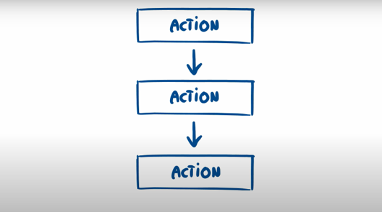

So every action has an input and an output and this goes for every single action. let's imagine for input we got a person object and from the person object, we extracted two properties, age and a name. That's going to be our output in a first action. What's great about this is that we can use now the age as an input to the next step.So now we are able to make some additional logic based on an age. Maybe calculate is this person an adult and now we have additional output, which we can use in a further steps as an input. But this is not where it ends because logic apps allow you to also grab output from previous steps. Like for instance, the name. This is very powerful feature because you are now able to combine multiple outputs from multiple steps and create more complex logic.

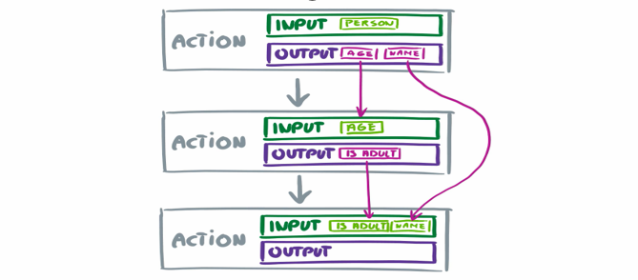

So, we have a certain set of actions, but we need to somehow start those actions. So, in order to start action and let's talk about starting of a logic app. So, first action in a logic app is actually called a trigger because it's a specific action that invokes entire flow. This trigger can be called by multiple sources. Maybe it's a web request. Maybe it's a schedule based trigger. Or maybe it's just an Office 365 event. Or maybe it's just a blob storage event where there's a new file. So, this is actually there's over 200 connectors that you can use for your integrations. There's a lot of things that you can actually use here.

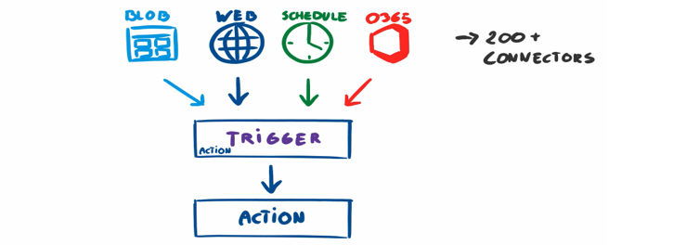

Let's consider simple example with a web request. We have a web request. We have a trigger that is basing on web request and following an action. If you would just move this a bit aside and replace this trigger with a block that looks like this when HTTP request is received and replace the following action by request response, that simply said is the most simple logic app that you can build.

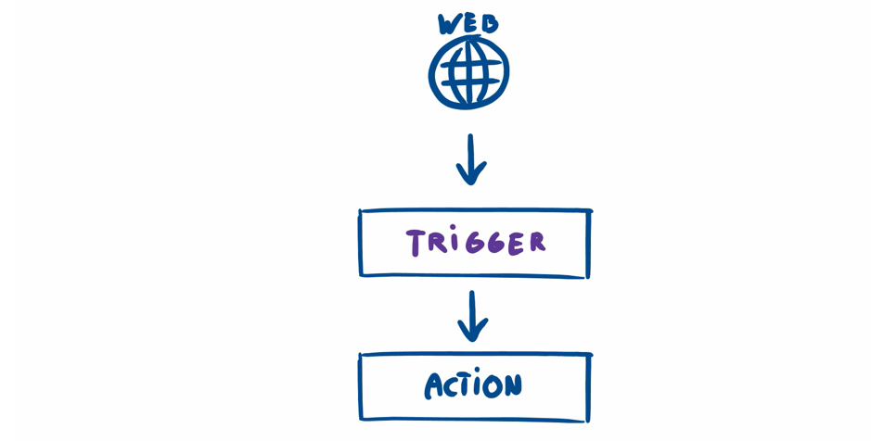

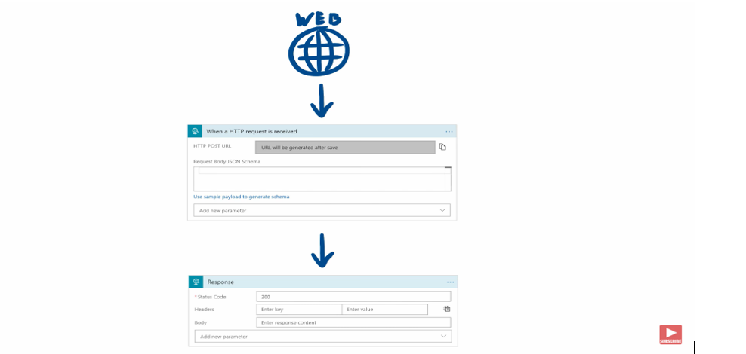

**First Demo -> Our first demo that's going to be happening today is this. We're going to have a user that's going to be shooting to the web request and going to get a simple response.**

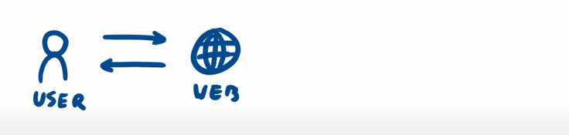

**Create Resource -> Logic App-> create**

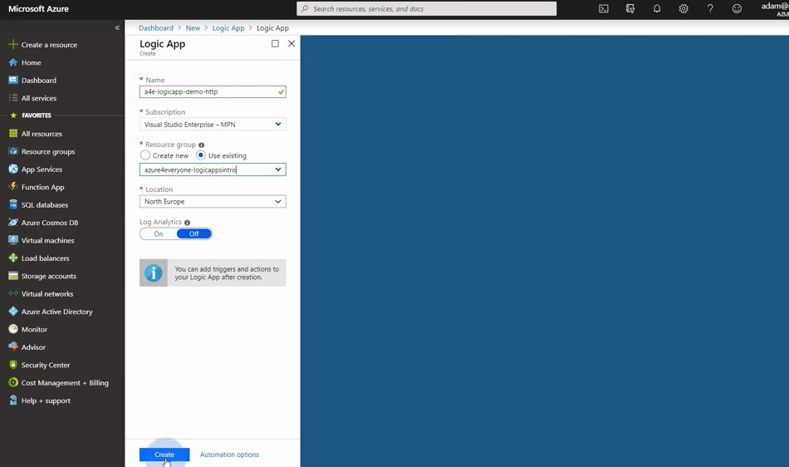

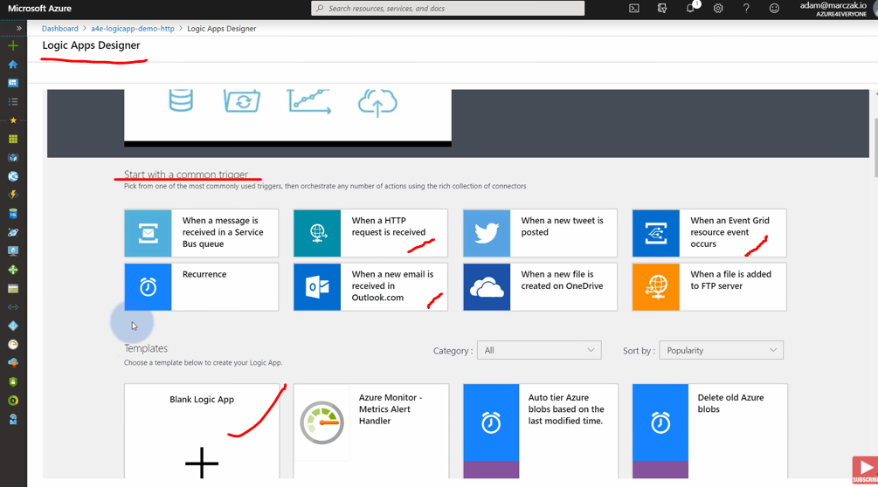

Go to Azure Portal. In order to create resource, we're going to hit create resource button here. Type a logic app. You need to select a subscription and a resource group. So I'm going to select the resource group that they created previously. you can go and hit go to resource. you are immediately moved to the logic app designer. This is your editor where you're going to be creating logic apps. So we are going to start with a blank logic app Template.

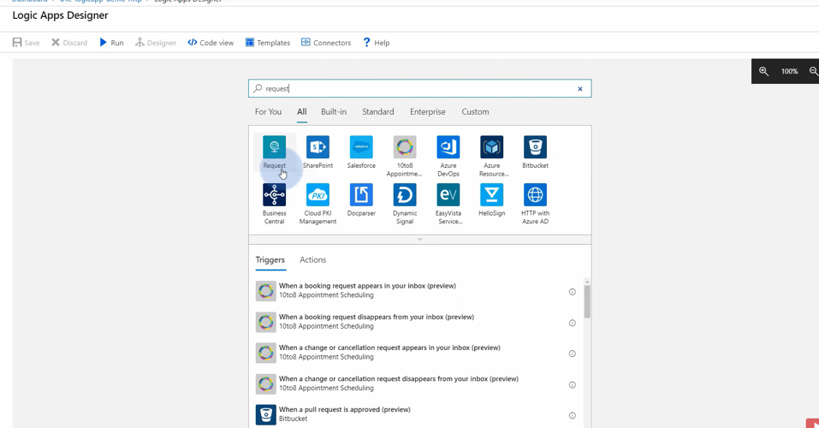

## 

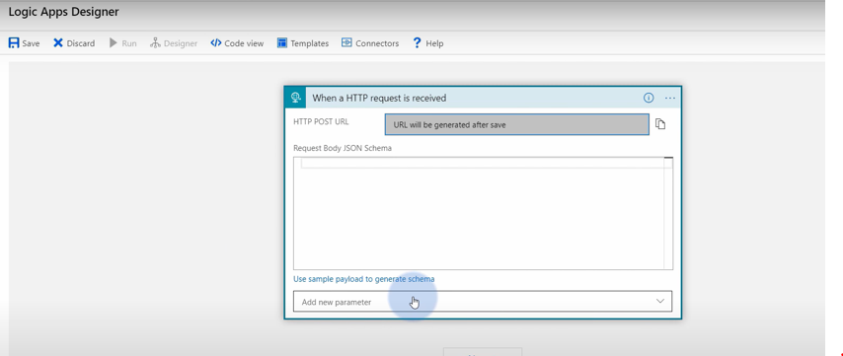

Since we want to create a web request, we just need to type request and select the first thing that pops up and now we need to specify what kind of request is this. So, there's going to be HTTP request that is being received. So, I'm going to select it. it says we're going to get a request URL after we save this. Now, even though it says HTTP post URL, you will be able to invoke this by get request and now, since this is configured, let's hide it and click new step. So, we now need to respond. So, let's type response. Notice on the below, we have a request response. This is an action that will respond to the user whenever the URL is hit. So, we want to respond with 200, which is success and maybe as a body, let's say hello world. and hit save. Our Logic App was saved. So, first of all, let's test it. You can always test it by using run button.

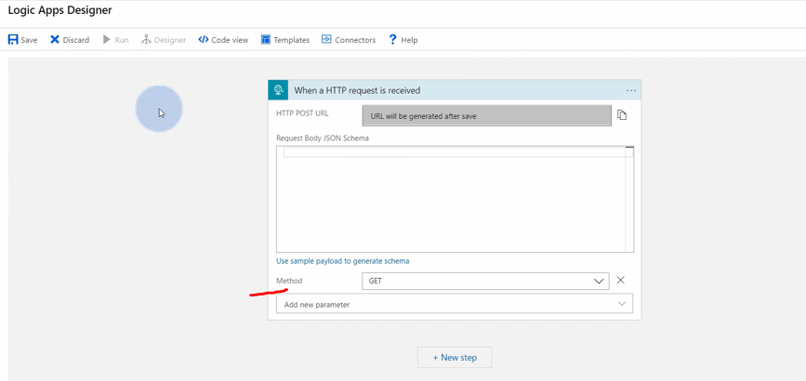

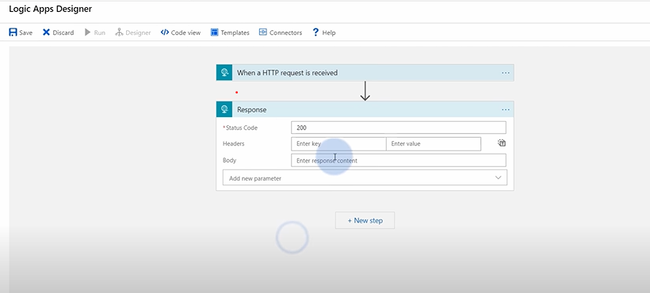

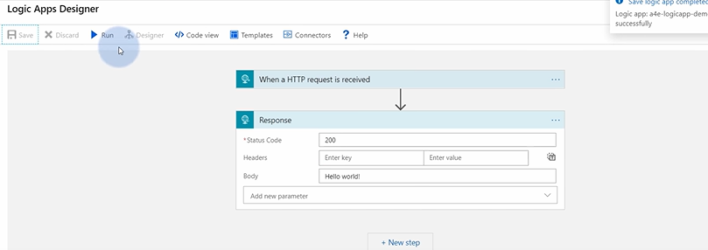

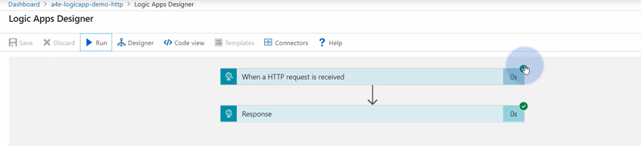

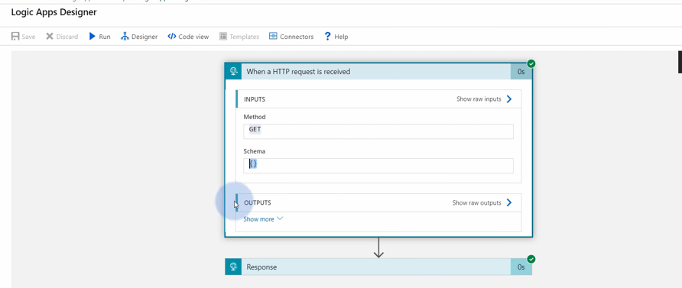

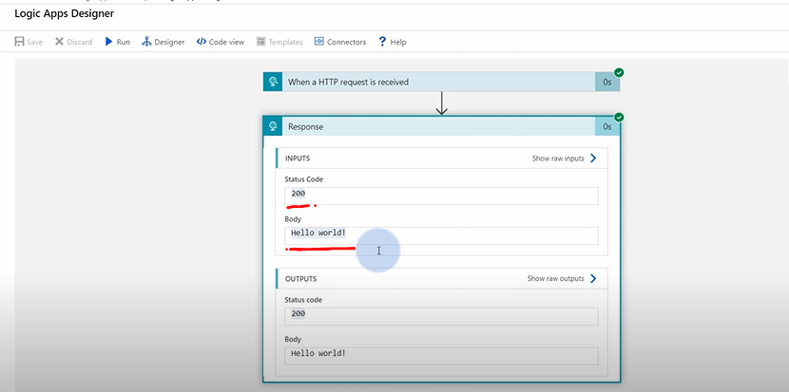

So, if this actually works, we can go back to designer, click on HTTP request and notice that this says now HTTP get URL, because we saved it. So, let's grab this URL, that you can pretty much copy into the browser. I'm just going to paste this URL here and hit enter.

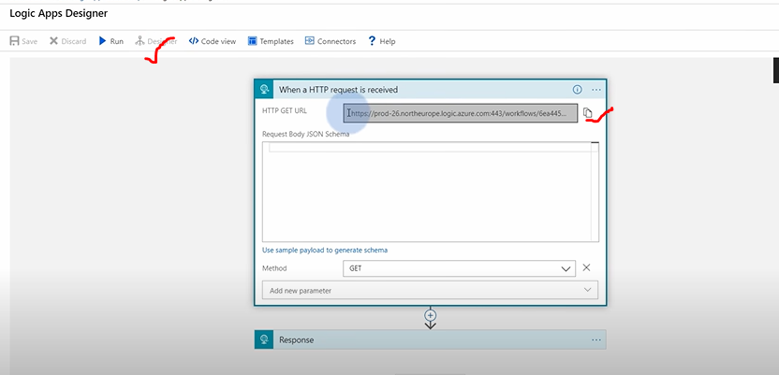

So, if this actually works, we can go back to designer, click on HTTP request and notice that this says now HTTP get URL, because we saved it. So, let's grab this URL, that you can pretty much copy into the browser. I'm just going to paste this URL here and hit enter. Notice that we got our response, hello world, which actually means everything is working just fine.

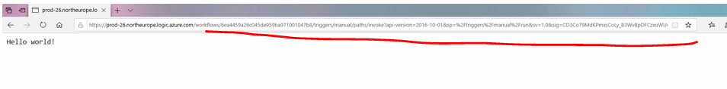

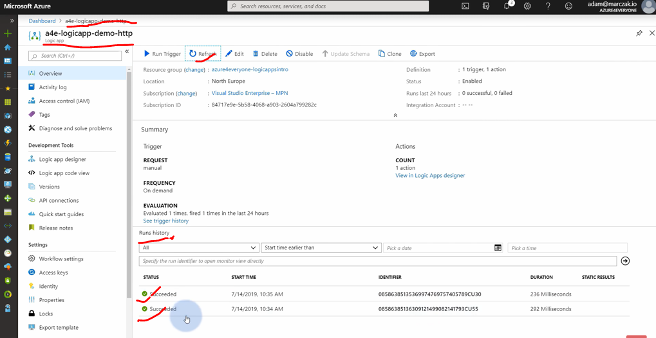

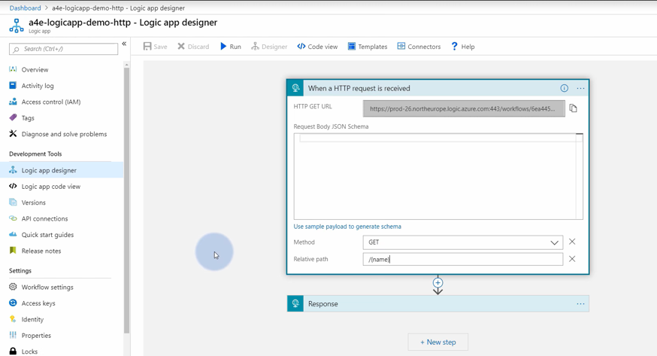

So, let's hit that URL again. Notice that our response now was Hello Adam. This is because of course we were able to pass and use a parameter in our flow.

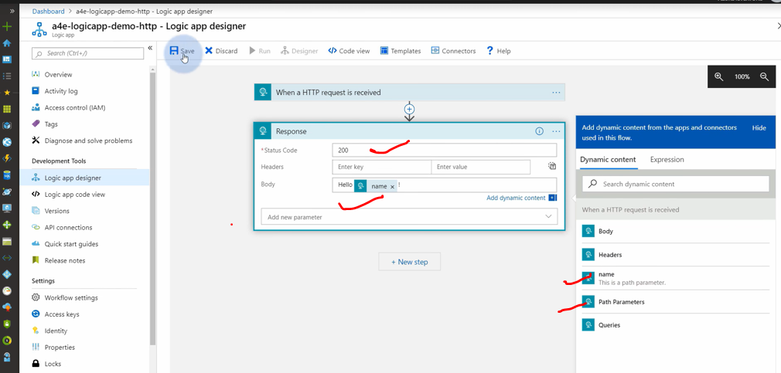

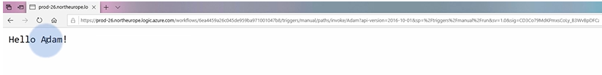

**Second Demo->** when we go back to response, maybe do something more complex. So, we just finished this example. Maybe we want to get a bit more complex. Let's maybe save every request that we created on a blob storage. Blob storage is a powerful service that allows you to store files.



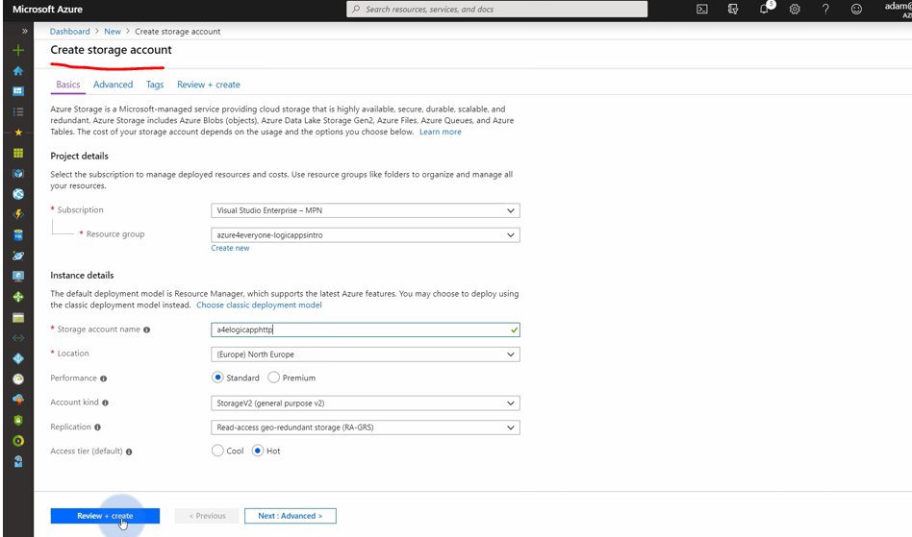

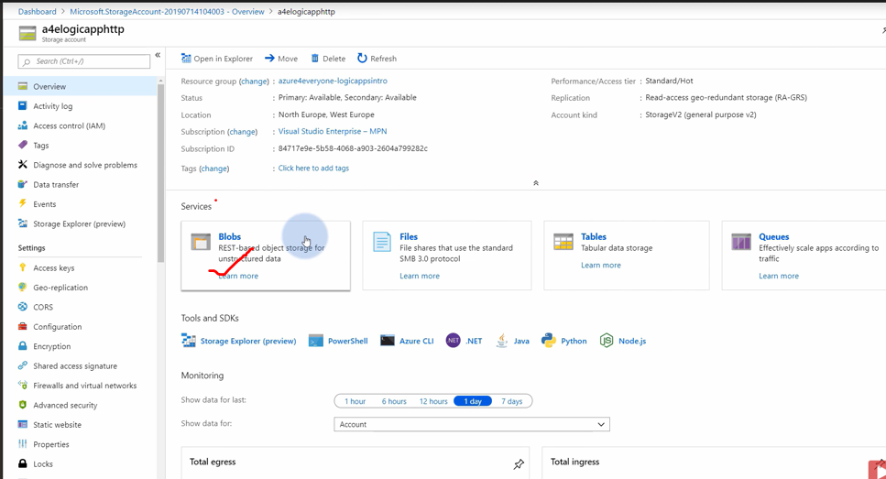

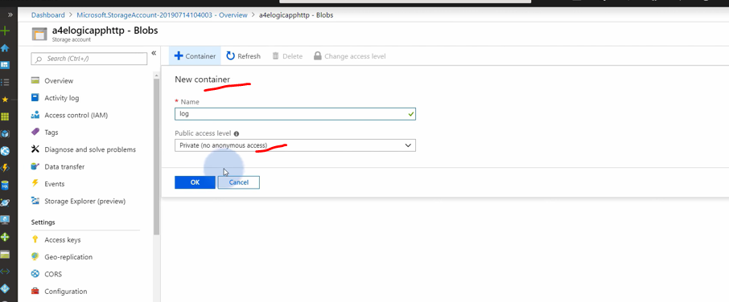

we don't have any blob storage yet, so we need to create it. So we hit create resource. We can type storage account, in order to create a storage account, you need to provide a resource group. We're going to create it in the same one that we already have. so, let's go to the resource, and this is our blob storage. We first always need to create a container, which is like a partition for our files. I'm going to create a container. It's going to be private because we don't want external people to access our files. I'm going to call it log. Basically, this is going to be our container containing all the files from our logic app execution. Since we have this set up, we can actually go back now to our logic app.

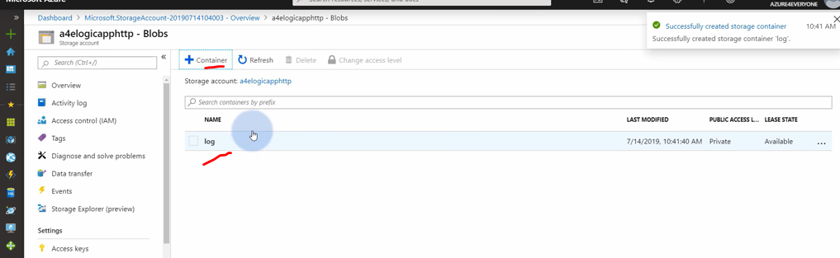

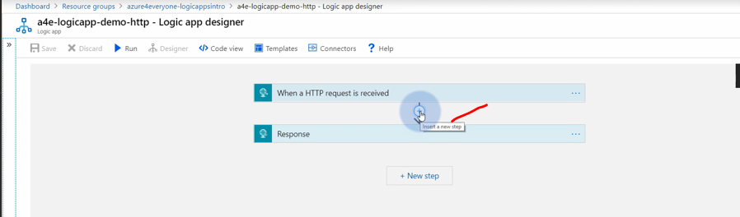

Now in the designer, let's go back to designer. Let's hit this button here, insert new step. This will allow us to add a step between a request and a response and add an action. Since we're going to be creating a blob storage integration, we just need to type a blob. First thing that will pop up is Azure Blob Storage. This is a connector that allows us to work with blob storage accounts without actually need of a technical knowledge. Let's hit it. We need to find an action that is called create blob because we're going to be creating new files. First thing that we need to define is a connection because our logic app is a public service, but our blob is a private service since we created a private container. It needs to know how to authorize and authenticate to this blob. We need to define a name. That's going to be our blob connection. We can either hit here because we already have access to our blob storage, or if this is external blob storage, you can enter connection information manually. For now, I'm just going to hit this and click create. What Azure does for us right now is connecting to this blob storage and grabbing blob storage name, URL, and an access key in order to create something called API connection. This is a safe connection information which allows logic apps to connect to blob storage in the future. Our connection just got saved. Since we want to create a blob, first of all, we need to select a folder. A folder is pretty much a container and then a path to the file. Let's hit it and select a log. This was our container that we just created. We need to specify the blob name. Maybe I'm just going to use a name, but we need an extension since those are files. I'm just going to add txt. We need also some sort of content, so let's just type hello world and a name. Instead of world, let's use a parameter. Notice that it says we don't have any parameters, but it's just hidden, so we need to hit show more, click name. Now, if this works, this means when we hit save and we go back to our URL and run it again, that means if we go back to logic app, we can of course validate if this runs successfully by looking at the log.

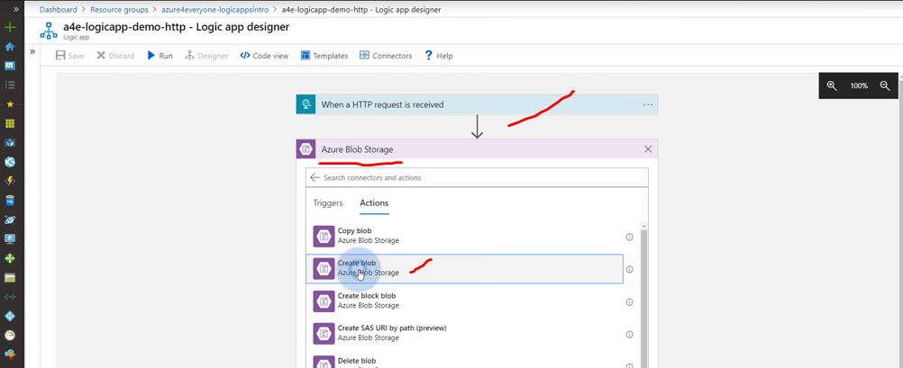

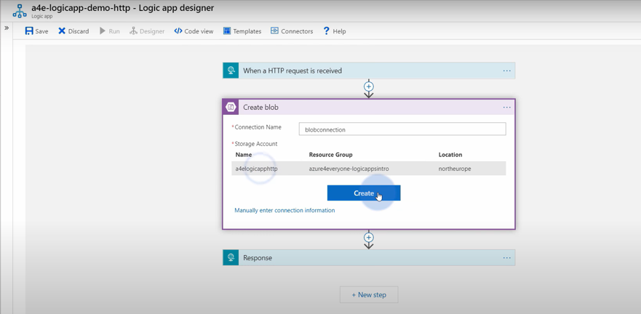

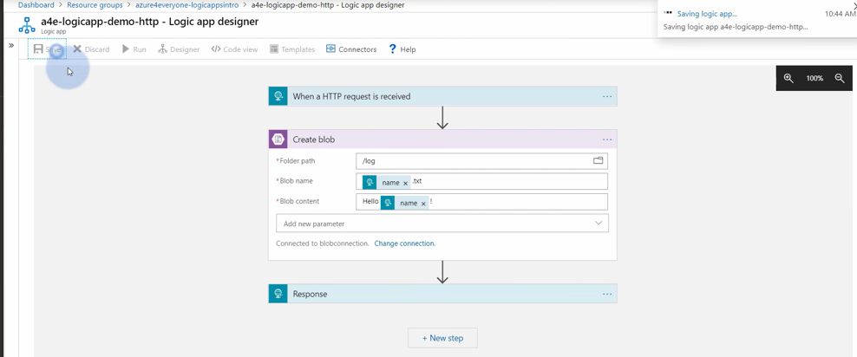

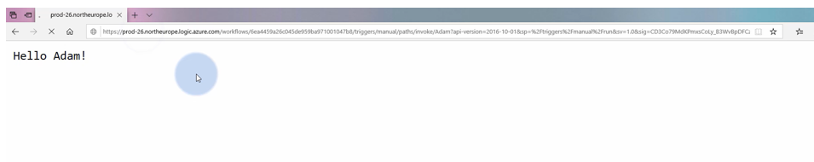

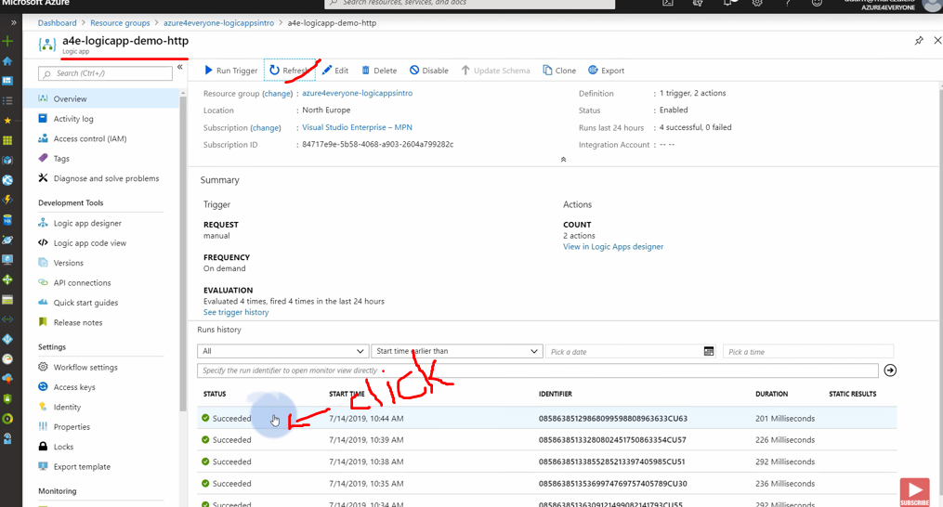

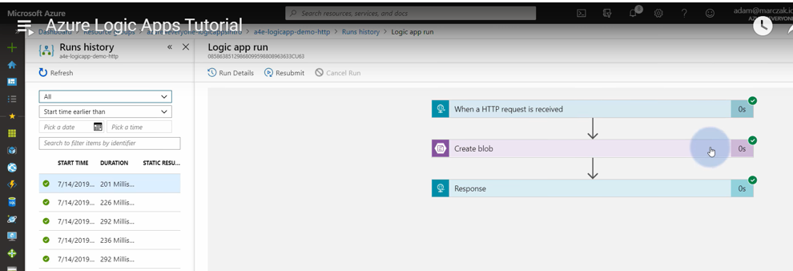

If this actually worked, we can go to our resource group and go back to our storage account, go to blob, log container, and see, this is our file, adam.txt. In order to validate it actually got created correctly, you can always also click on it, go to edit blob, and see the contents. This is great. Let's go back to our logic app. Let's do something a bit more complex.

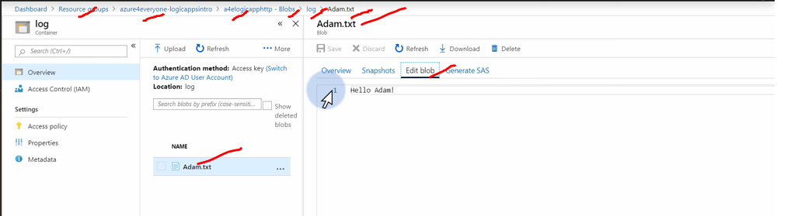



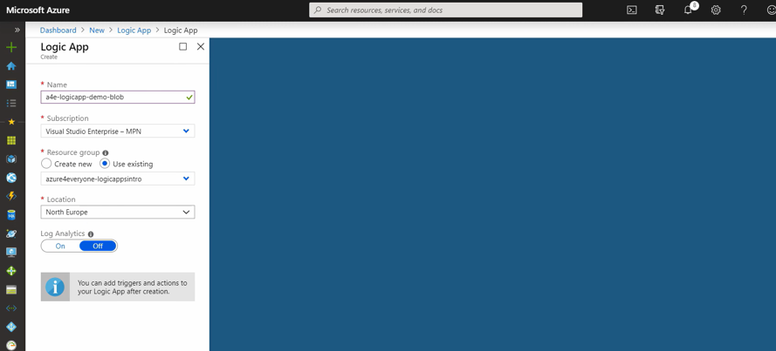

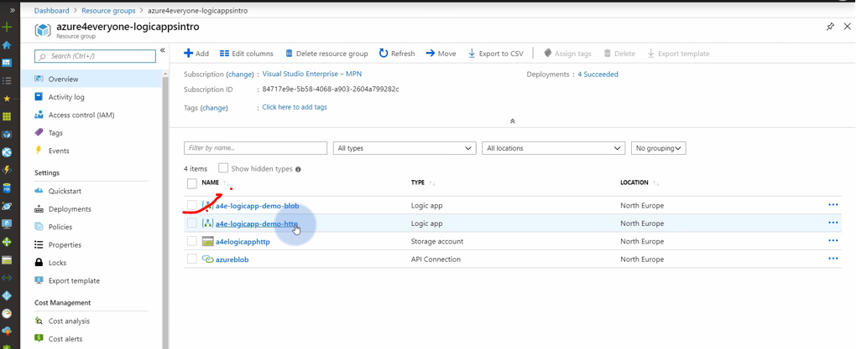

**Third Demo** let's create another scenario where logic app reacts to the new files on the blob, and after new files appear, it will send us an email. Maybe let's do that with an outlook. In order to do that, we will need another logic app, because this one already has a trigger, and it's a HTTP trigger. Right now, we will need a trigger that reacts whenever there's a new blob. To do that, we go to new resource, type in again logic app, hit create.

Notice that because I actually kept the naming convention, they're nicely aligned, and I know very quickly that this is a blob, and this is HTTP logic app. Go to blob storage. As usual, you're prompted with an empty designer, so let's start with a blank logic app, and let's type blob. As you see, we don't need to type blob, because we already worked with the blob connectivity, and Azure remembers that through the cookies. We can actually hit Azure blob storage here, and there's only one trigger, which is called when the new blob is added or modified. Let's use that.

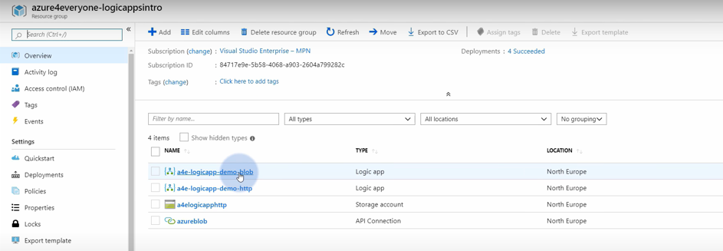

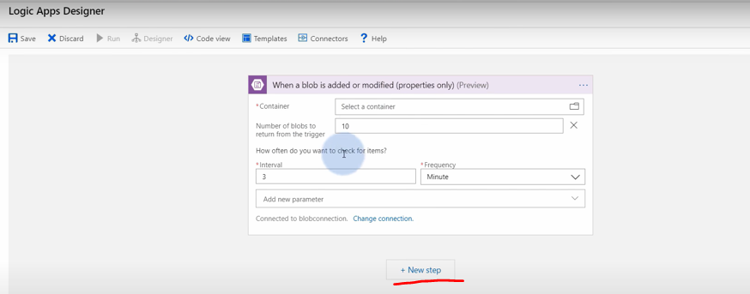

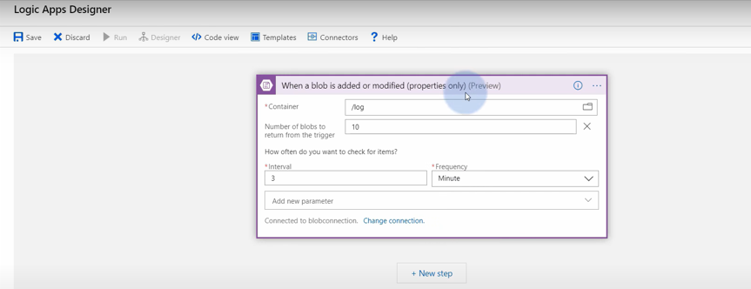

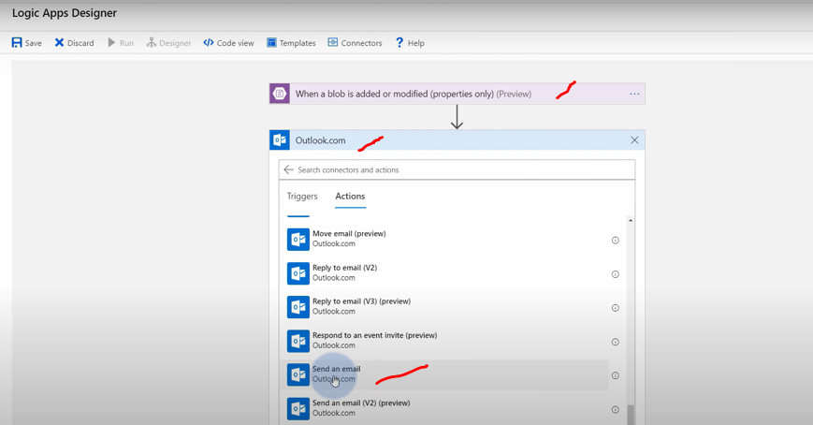

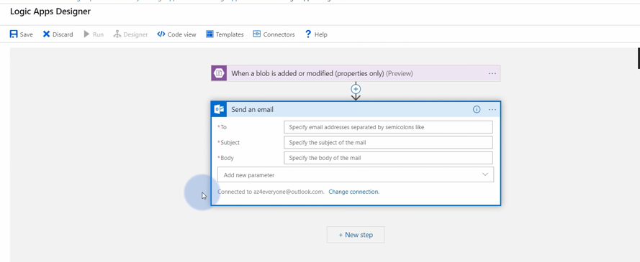

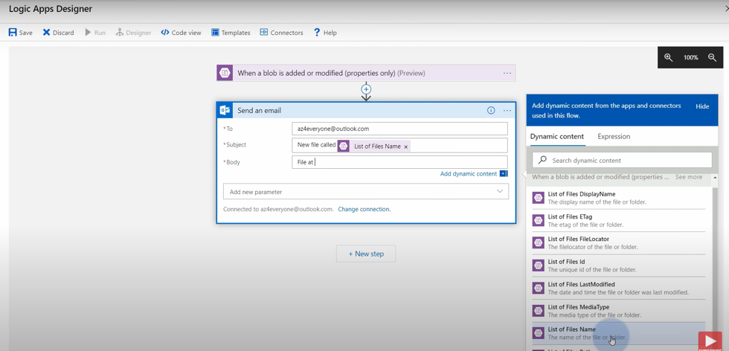

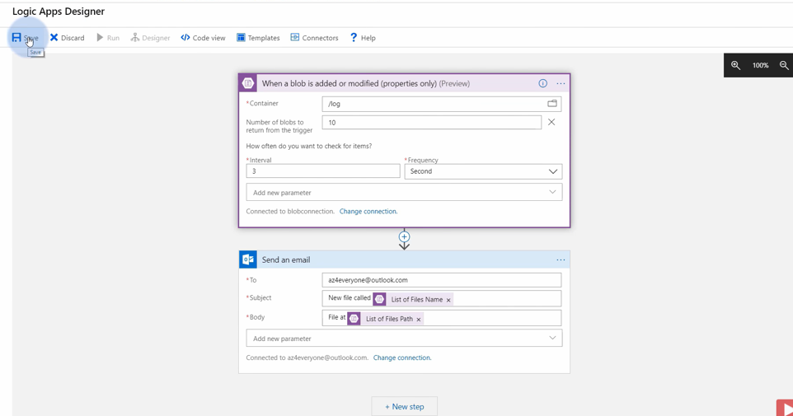

if this Logic Apps right now works, notice that we already are getting emails. We got a new file called adam.txt file that was saved at log slash adam.txt. So, we created also John and Tom. See, we already got them. But in case something would not work, you can always go back to your Logic App, refresh here, and check the execution if you missed some steps. It's a powerful feature that will also tell you if you missed something up. Let's go back to our diagram. As you see, we are able to implement something called function chaining using Logic Apps. It looks even better as a nice diagram using Visio. And that's pretty much it.

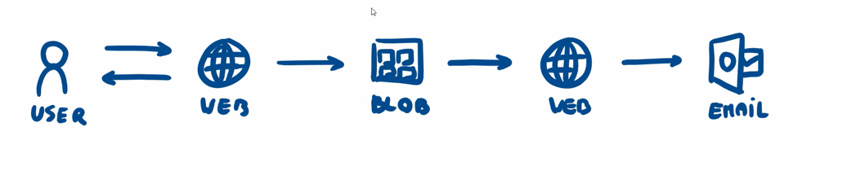

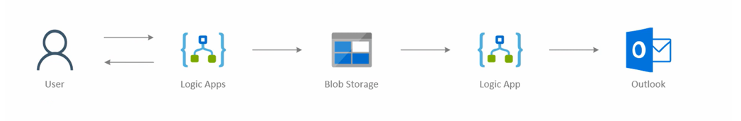

**Azure Function App**

**Introduction for Serverless Programming**

* Hey there, this is Kaushal again and today we're gonna be talking about serverless because it's probably one of the best concepts about the cloud. Managing the code without managing the servers or the infrastructure. Today we're gonna get introduction into Azure Function Apps. Probably one of my favorite services.
* Functions is a service for running small pieces of code, so you have that script in .NET or maybe Java or any other languages that is supported this is the place to go and they call those small pieces of code functions. This is a great service and very cheap service very scalable service for running serverless because you don't have to manage infrastructure. What is important is that this service is extension of Azure App Service
* So how function works? Function is a piece of code we already said that but in order to execute that piece of code you need something called trigger. A trigger is an action that will involve this code and will pass some basic information to this code in order to run and of course code when it's done it has some sort of an output For instance you can bind to a blob storage so you can trigger a code whenever there's a new file available on a blob and you can maybe process that file and put it back on a blob storage.

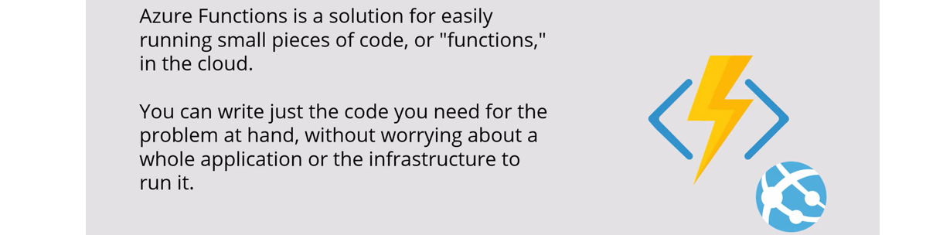

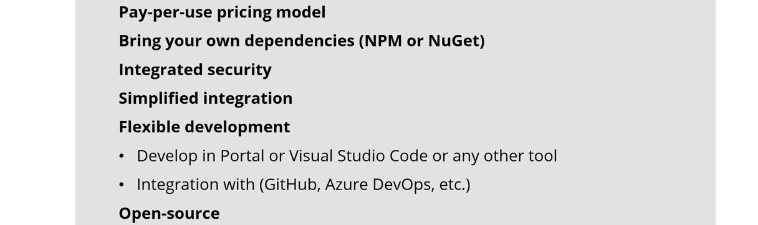

**How Function App work-**





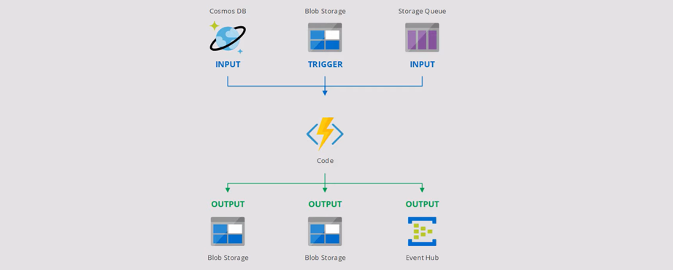

So, we're processing data from the blob storage, and we want to output into the blob storage. So, this is the piece of code that grabs the file from the blob as a trigger. So, you have a blob trigger defined here and you do it in a way that you pass a parameter, and you specify blob trigger that tells our function that we are triggering every time there's going to be a new file on the blob storage.

Second of all you specify in which container should you check. In this case it's going to be **sample work items**. So, function will check whenever there are new files in this container and trigger whenever new file appears or is modified.

## 

## 

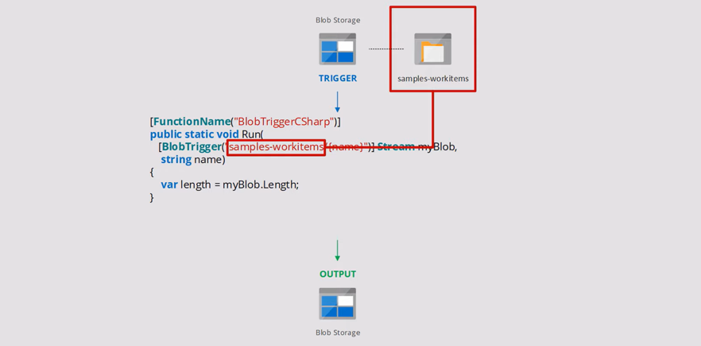

Next you have something called expressions. So, in this case you use expression to grab the name of the file that is being processed. What is good here is that you can use this expression to pass the name of that file into a variable of the same name. That means in this name variable right now in this parameter you will have the name of the file or actual full path to the name in that variable.

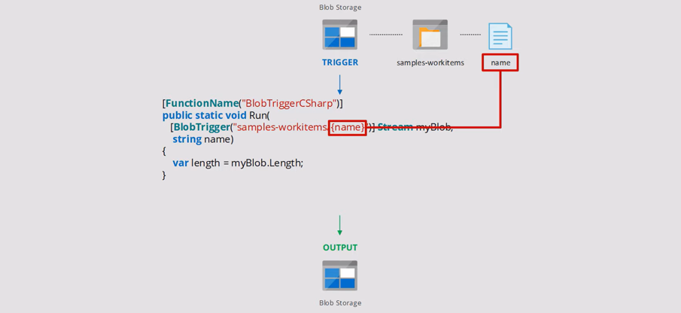

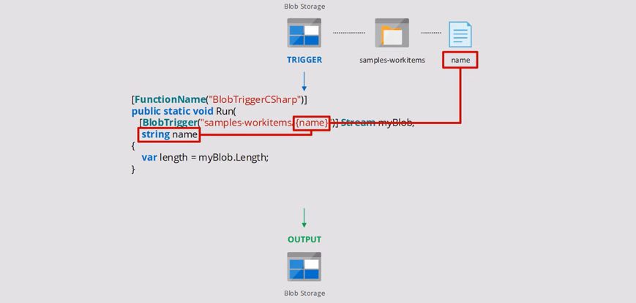

Next and lastly for this trigger you need to define the variable that you will put your contents of the file in. In this case it's a stream so we're gonna put the file and all its contents into my blob parameter.

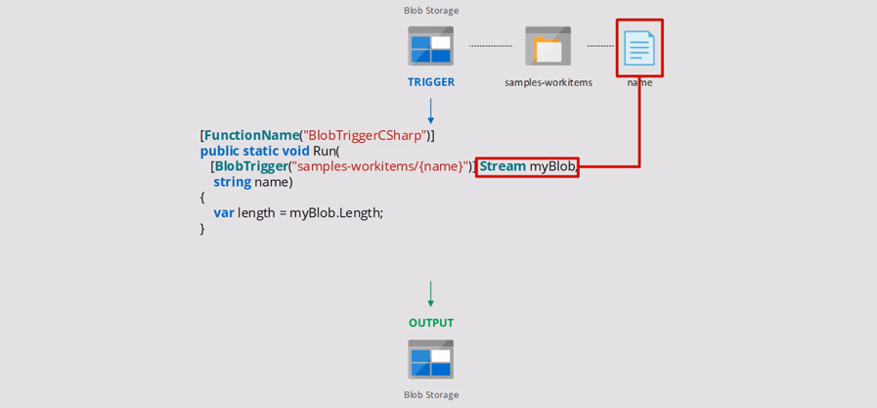

And lastly if you want this output, you just add additional line saying blob this is no longer trigger so it's just a blob. You specify the container name, you specify the file access which is in this case writing because we're processing the file and you can just type a blob copy to output blob and this is with one line of code you're making a copy of blob into additional container into additional storage.

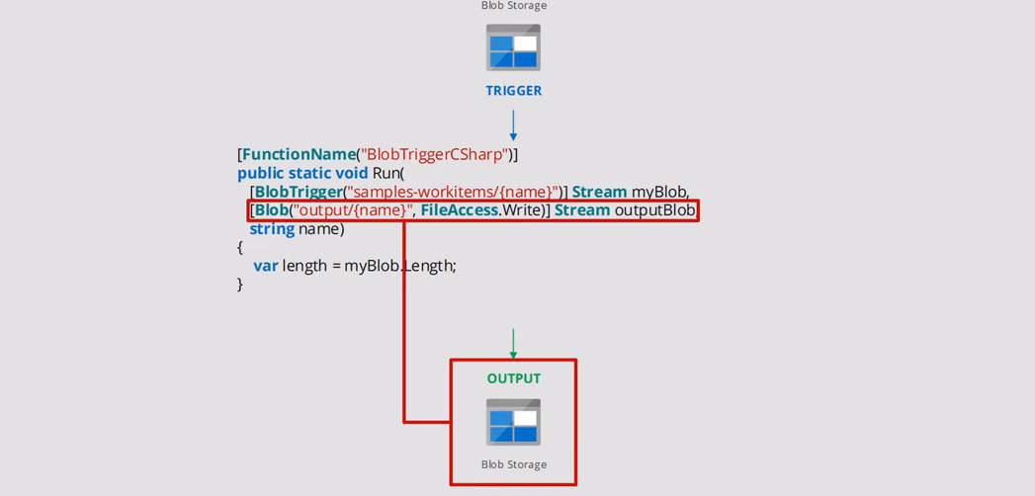

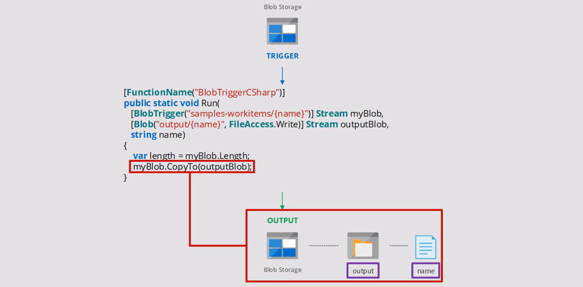

**Triggering & Bindings-**

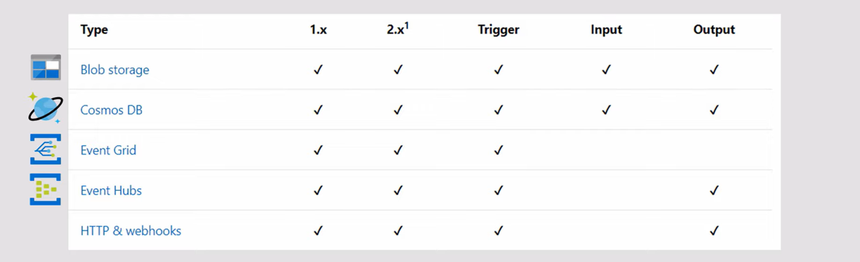

So, let's go into the portal and start creating the service. In order to create new service, you need to hit create resource and type function. I'm gonna call it **a4edemoapp**. Consumption plan is this serverless plan which means you don't manage any servers. Azure will give you servers whenever there's a processing happening. Whenever there's not it will take away those servers. So, you have between 0 and 200 servers available at hand and of course Azure decides whenever you need those 200 servers or not. If you're gonna be processing a lot of data Azure will keep giving you additional servers and your data will be processed faster.

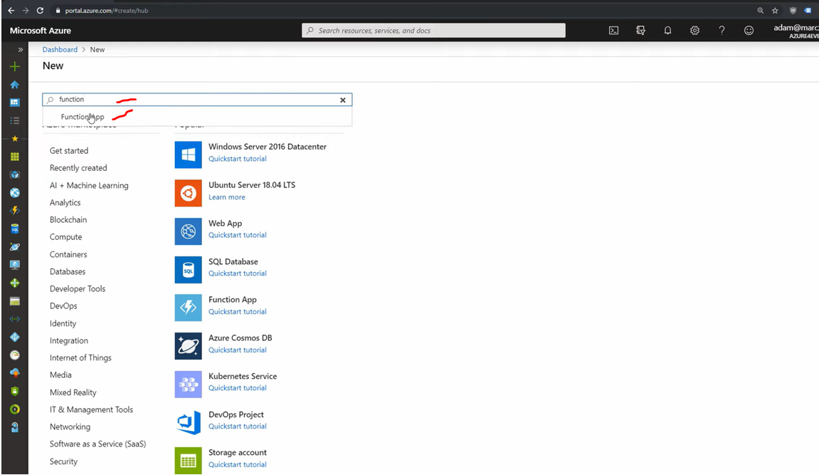  
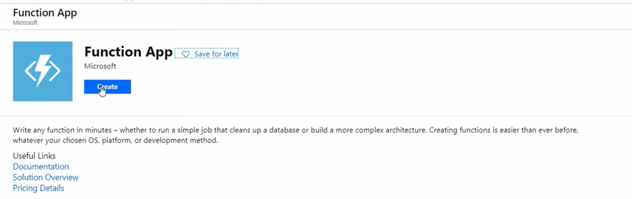

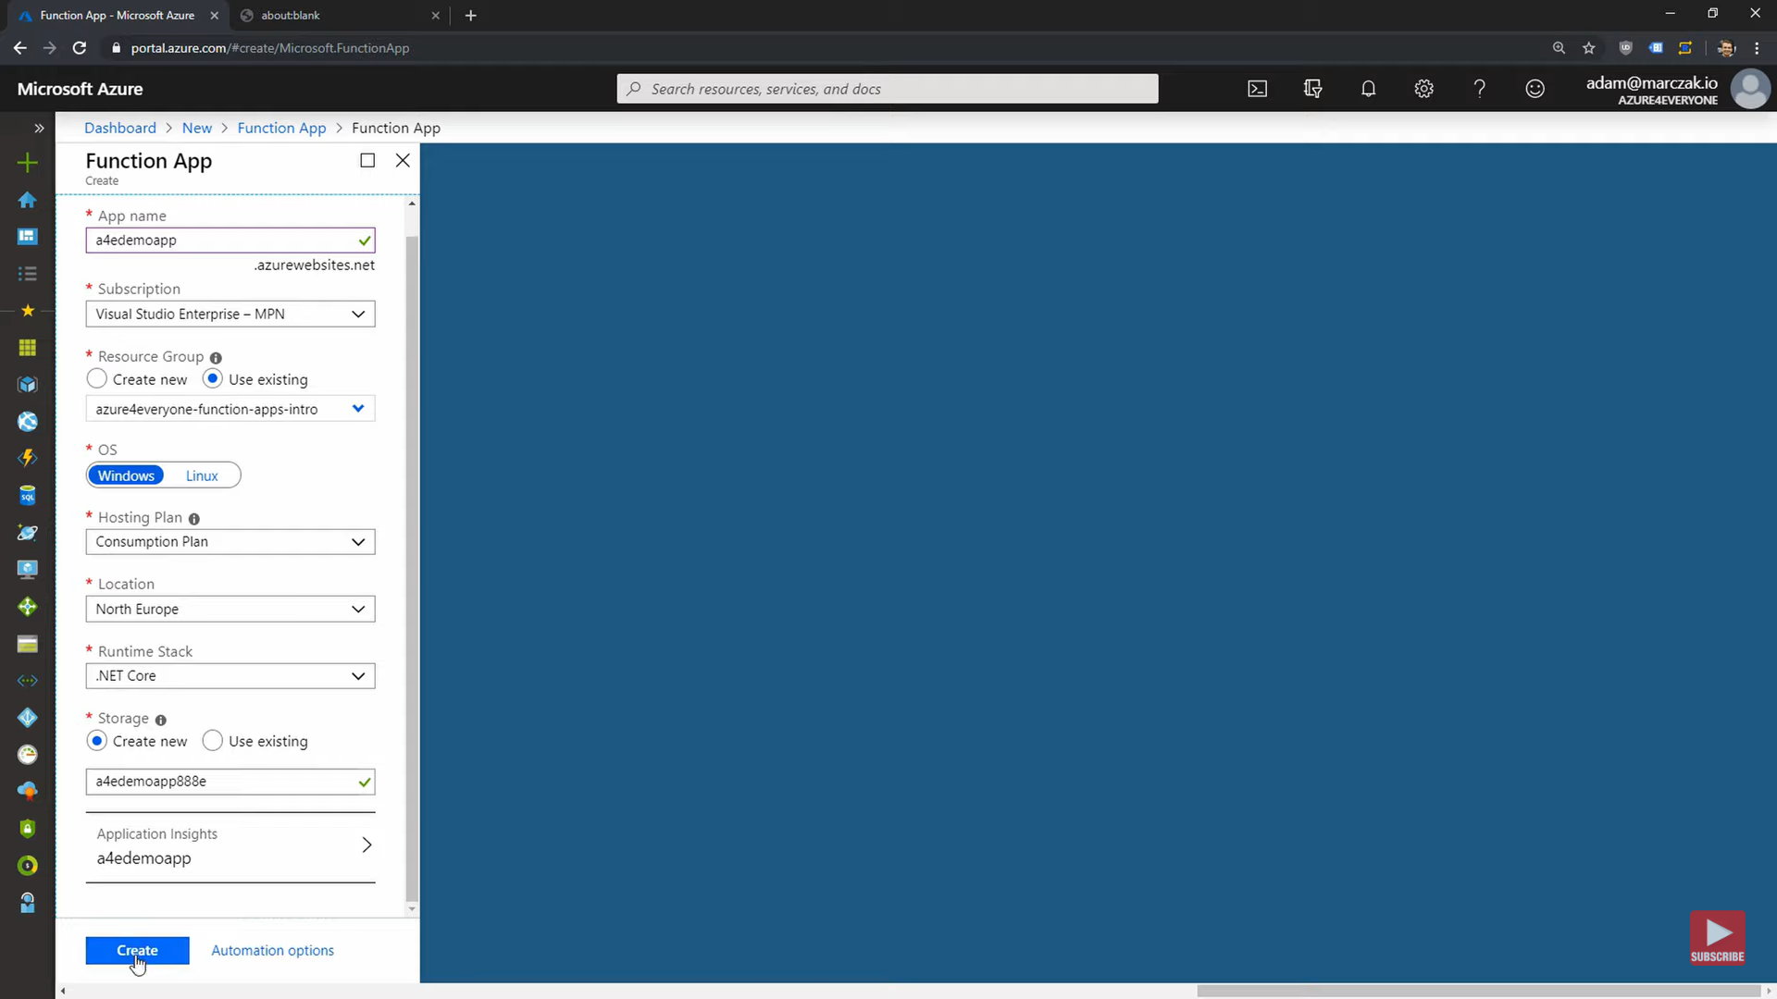

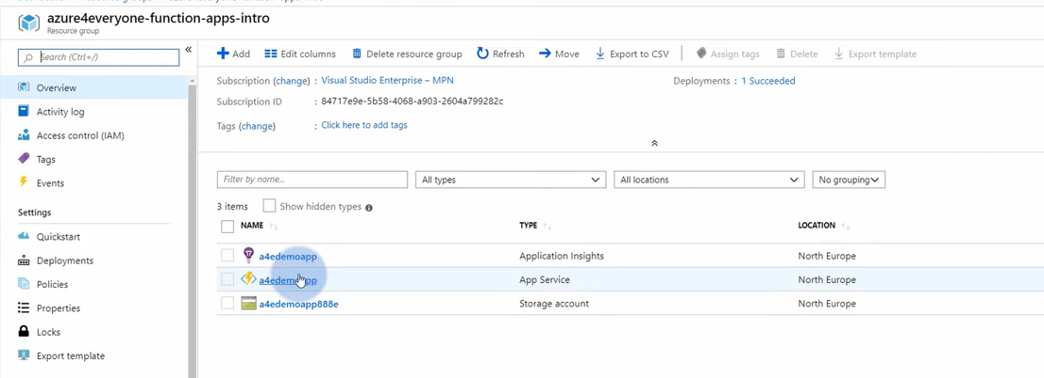

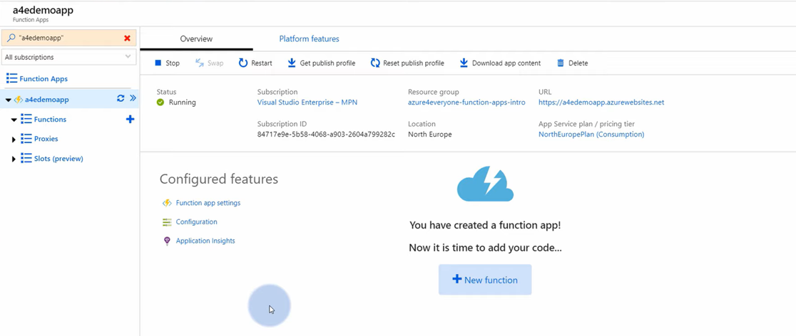

I'm gonna choose storage. Interesting why do I need a storage? Because everything that you do in functions including functions code is stored on a storage. As you can imagine since functions are serverless you don't have a server therefore you don't have any place where you can put your code in and save your state. This is where storage comes in. Entire code base of your functions and the state of your functions are saved on the storage so whenever new servers are initialized, they grab the code from the storage.

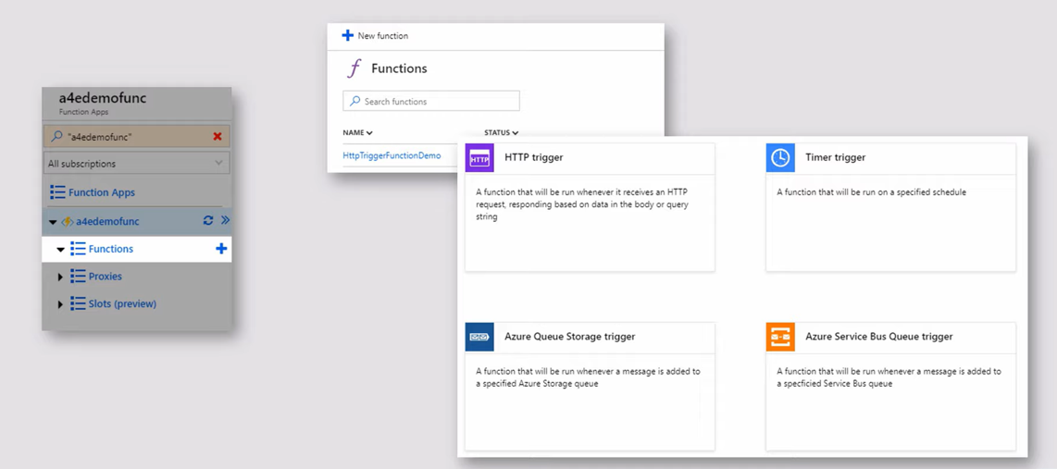

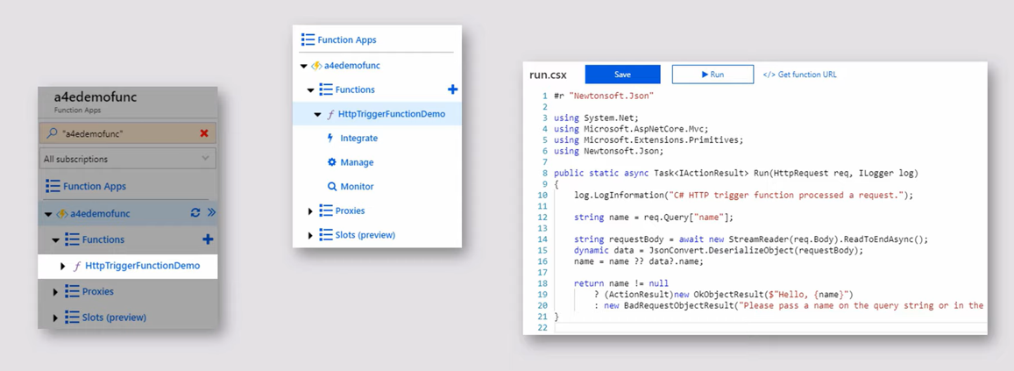

**Important**

* **Actually, we have used this Http Trigger Webhook API function in our project for converting date and currency in a specific format. We are just calling the webhook api just passing the input parameter as currency or date value and get output as an required format currency or date formatted data output.**
* **Actually, we have used Logic App as well where our all payment and receipts scanned documents are stored into a blob storage from where we are picking and digitizing and converting in Json format using cognitive services and that json documents storing into our blob storage.**

let's create a quick function so let's go to the function tab let's hit this button to create new function from the quick start we're gonna choose that we want to develop in the portal I'm gonna hit continue I want to create a webhook plus API which is this HTTP trigger so I'm gonna hit create and in just couple of seconds I'm gonna be presented with a standard template for HTTP triggers. okay I've got it and notice that it is tiny bit different that what we were talking about because you have here HTTP request it's not HTTP trigger and then this is simply because working with HTTP is tiny bit different than working with other triggers but don't worry about it this is the most simple version of the HTTP function that you can write so you have some logging here that we've been processing request this says that grab the URL parameter called name if there's some parsing and if there's no name in the URL return the message that URL needs to be submitted if it is say hello and name so let's see if this works.

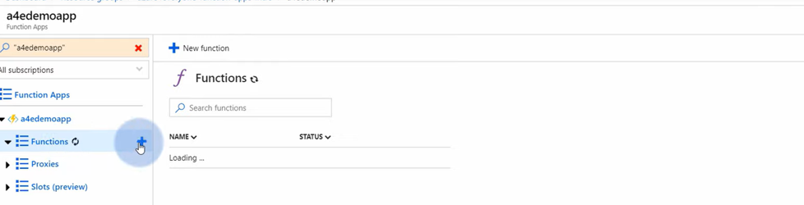

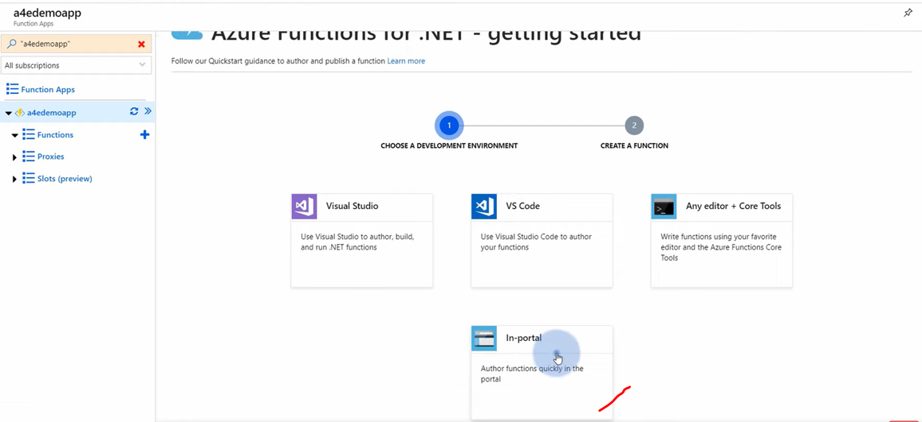

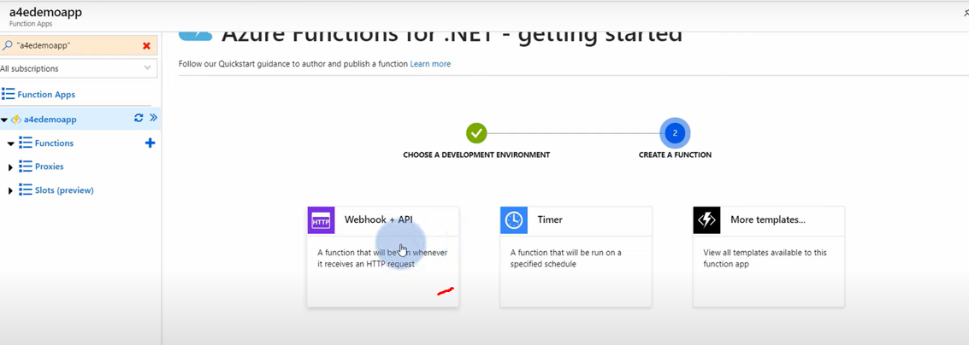

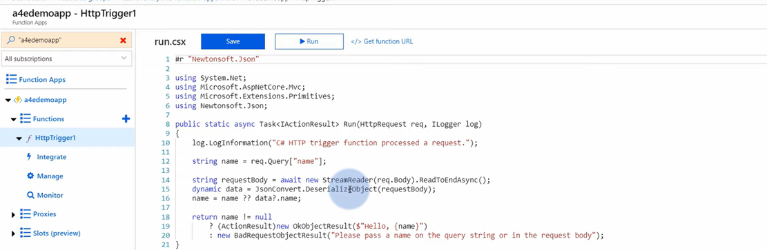

you can test it two ways you can either open this panel on the right-hand side click on the test tab and send a request body or a URL parameter scroll down this UI is not the best but there's a run button here executed, and we got hello Azure so it works but

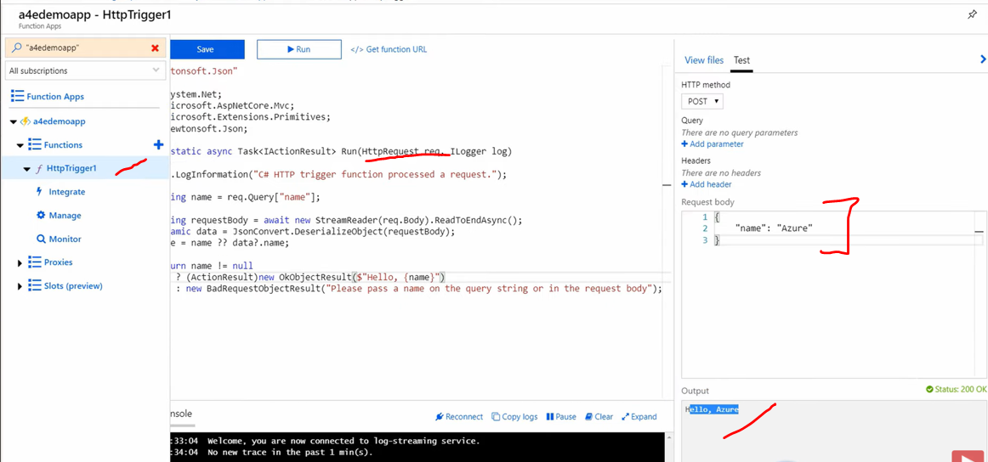

But you can also test it just by grabbing the URL yourself going to another tab pasting the URL hitting enter of course please pass the name query string we didn't do that so let's do that, so my name is Adam and hello Adam so as you see it works.

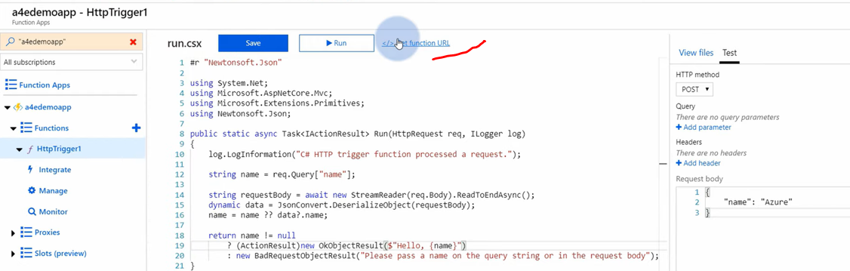

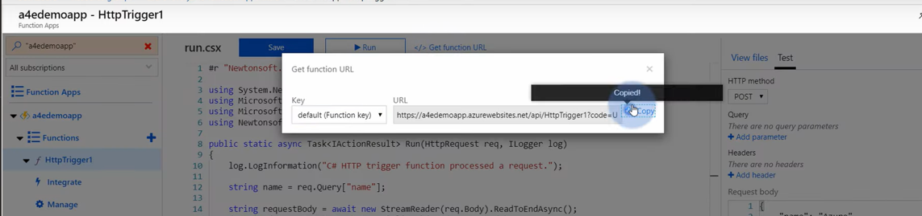

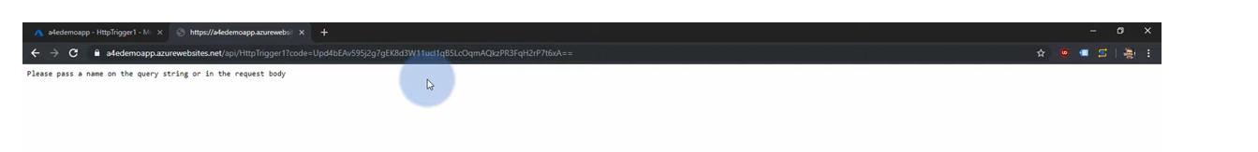

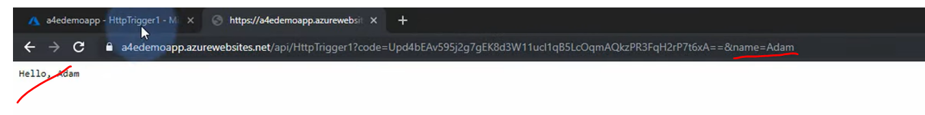

Let’s create a function using Visual Studio code

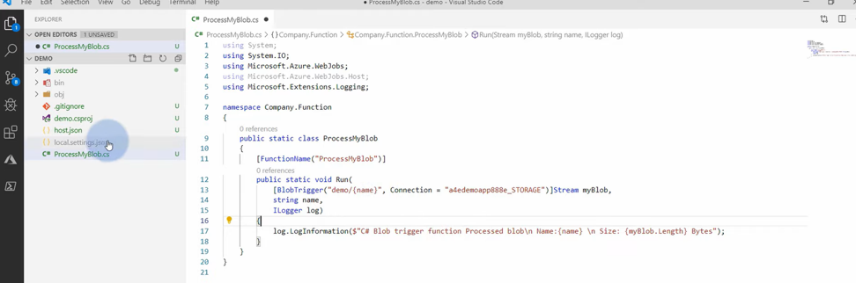

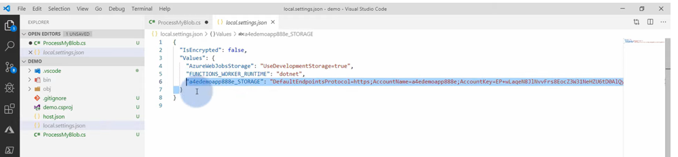

Let’s remove this line bcz I don’t want to create a new storage account.

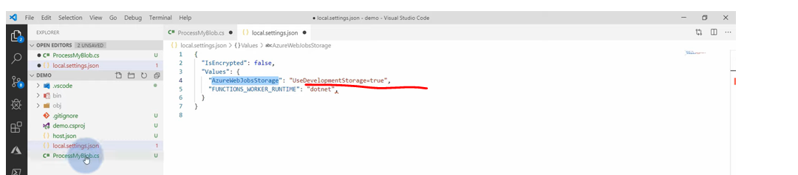

I just want to use my existing one…

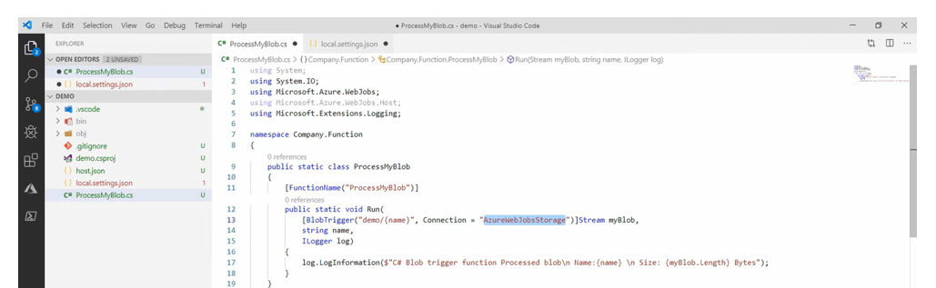

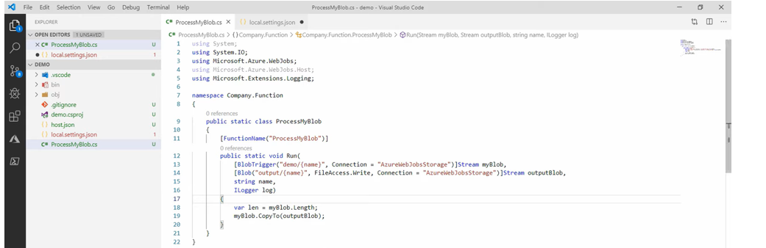

Now let’s quickly build & deploy this app.

Now let’s create 2 container demo and output. let’s upload one text file in demo container then we can see our demo container also having the same content file.

Because our function app we deployed .

**Azure App Service (Web Apps)**

**To Deploy our Web Application on Azure Cloud**

* Build & Deploy a Spring Boot application to Microsoft Azure using GitHub Action

Let’s see how to make our spring boot application to work on azure platform. There is a multiple way with which you can host your application on azure platform. You can use either github or Maven plugin.

In this we are going to use Github and also, we are going to use Github action to automate our build and deployment. So go to Azure account portal and we want to deploy our web application so directly jump into App Service.

So, first of all we need to create one Resource Group.so, its like a container to hold all resources and services on azure cloud.

let's talk about web development. Because whatever you're doing front-end application or some RESTful API, you need a service to host that. we are going to learn about Azure App Service. So, let's find out how we can use it, shall we? Let's start with introduction into App Service. If you've ever been hosting web application before, you've already probably been using some sort of hosting environment.

This is a hosting environment in Azure. It allows you to host web application, mobile backends, maybe some RESTful APIs.

Let's create and deploy our web application.

* **Integration with Spring boot application on azure cloud deployment**

Application Name - **spring-integration-azure-app**

Created Github repo- <https://github.com/kaushal8707/spring-integration-azure-app>

Developed and commit our code to this github repository

**Go to Azure-> create Web App Service-> Spring-Integration-azure-app**

Go to Deployment Centre

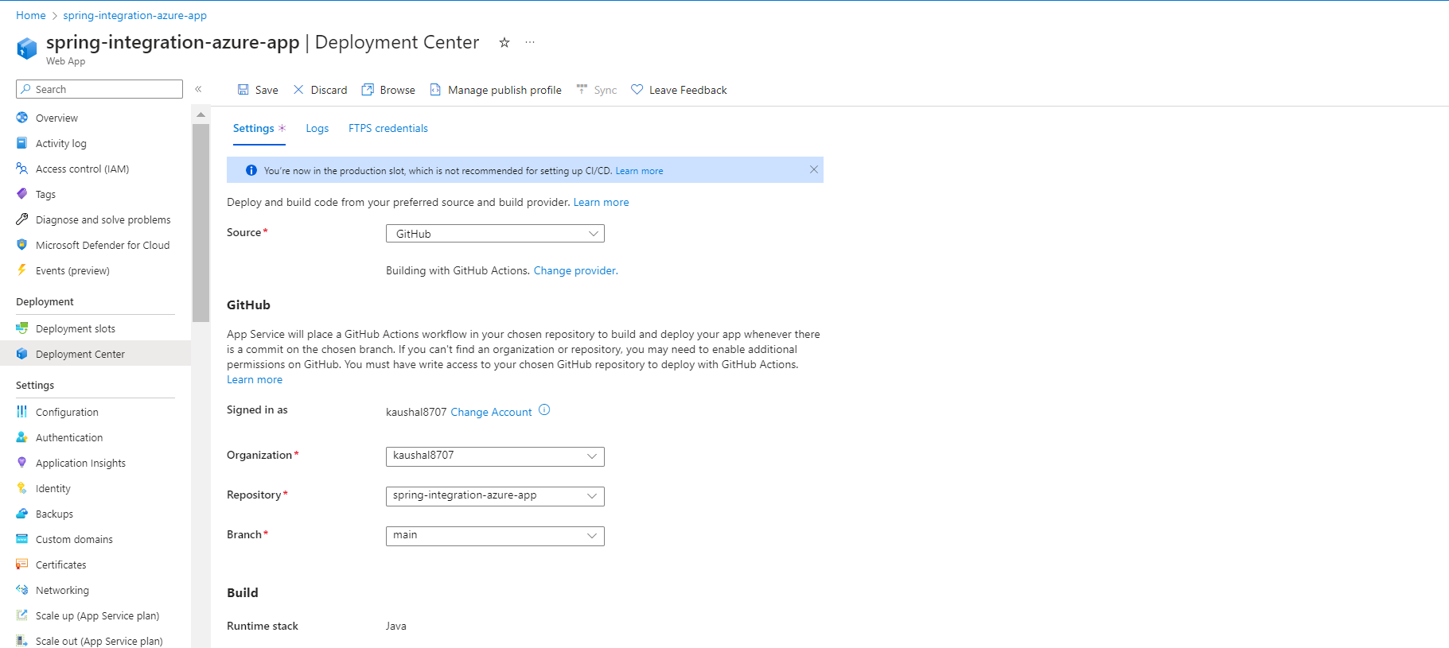

Copy this deployment file .yaml in README file of Git repo.

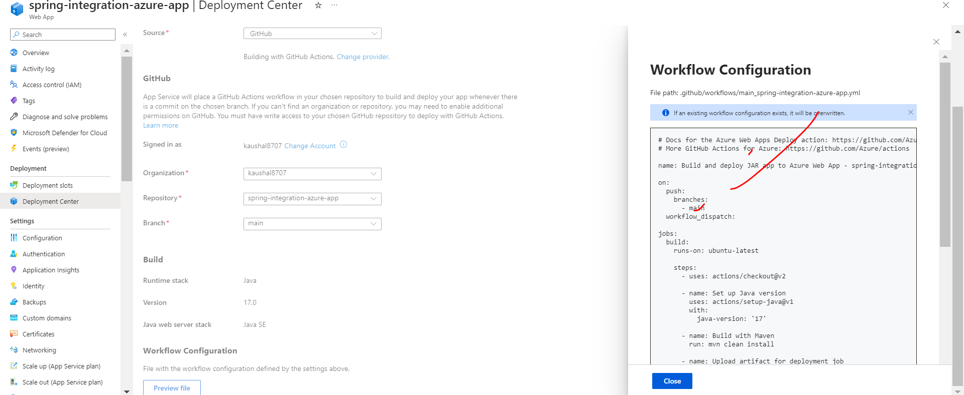

Now save this app on azure.

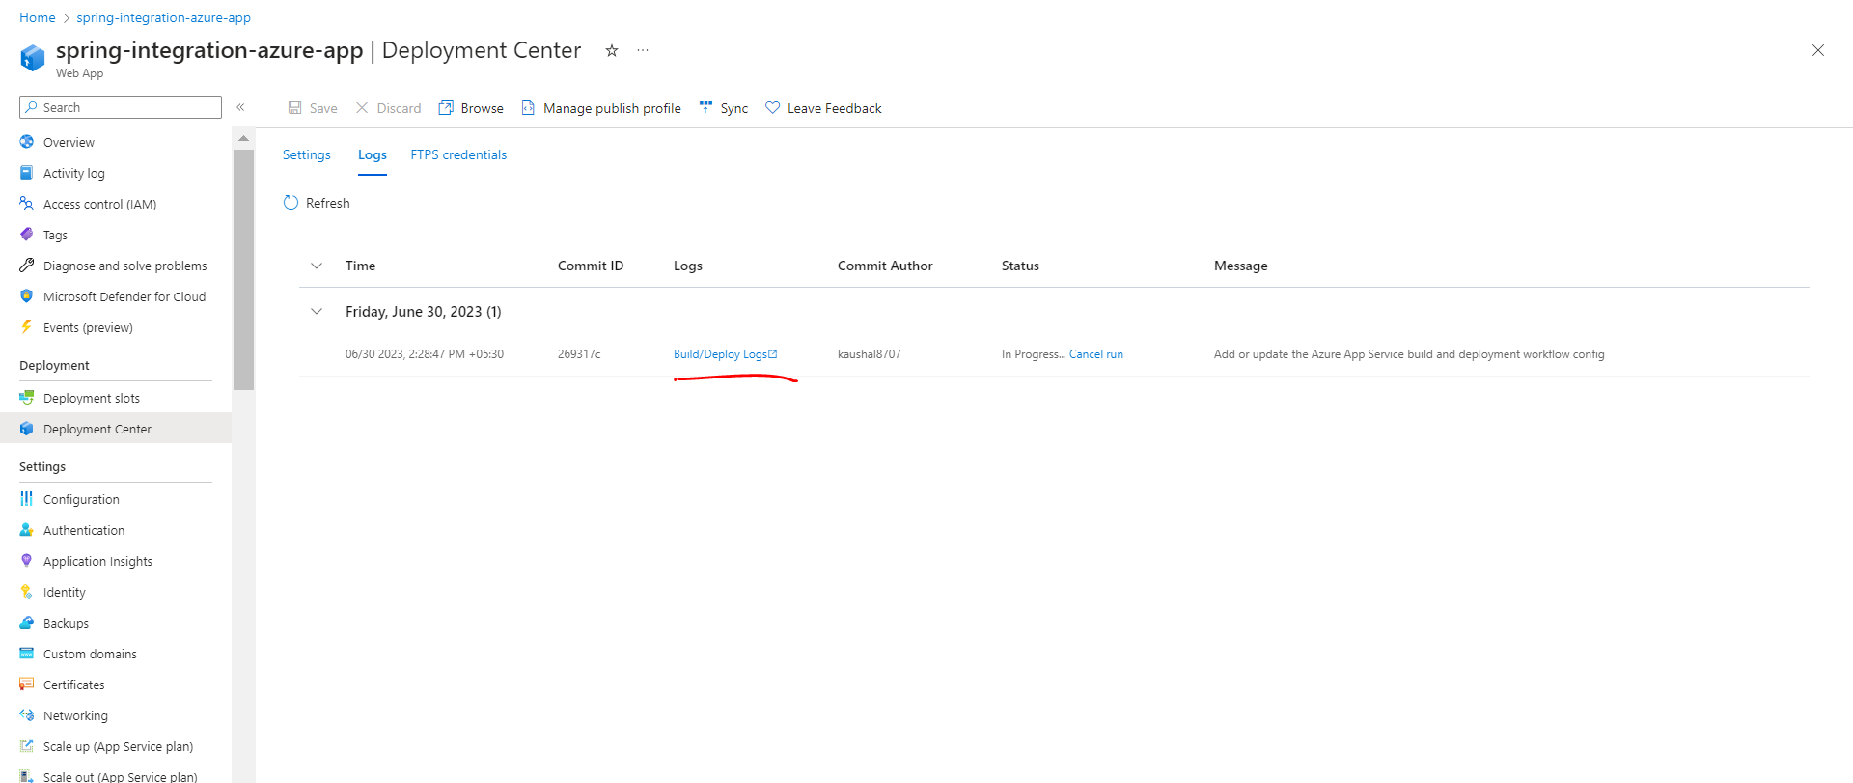

Open this build and deploy logs.

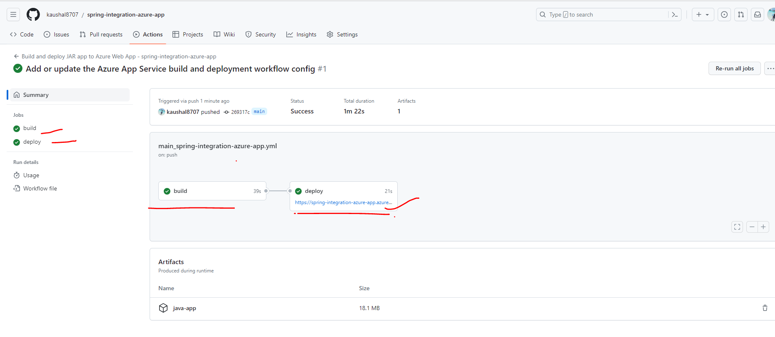

This is what the Git hub action.

Now deployment is done…so copy the URL…and open it in browser.

URL- <https://spring-integration-azure-app.azurewebsites.net/message>

Let’s hit our rest endpoint and see the response.

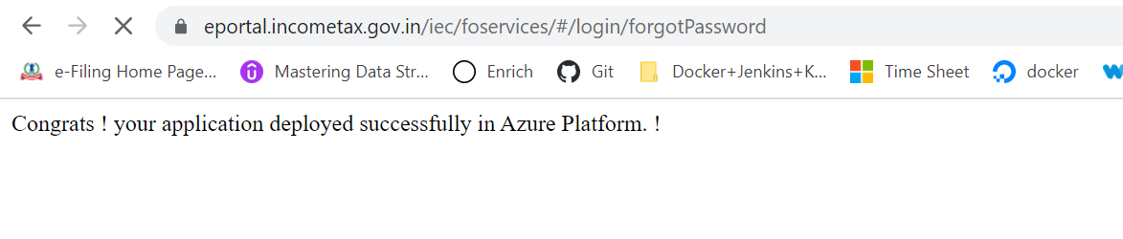

**Azure SQL Database**

**Relational databases in Azure**

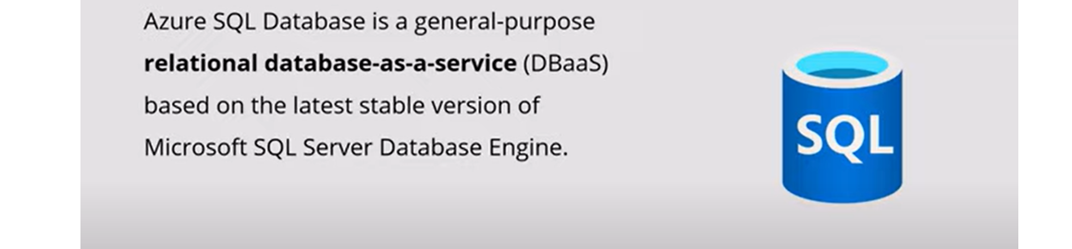

* Today we're talking about SQL database. If you need to manage, query and ensure structure of your data in database, this is one of the primary services to do so.
* So, SQL database in Azure is a relational database as a service. That means it's a latest stable version of Microsoft SQL Server database engine in a cloud.

So, in case you have an entity called person and this entity has three values, first name, last name, and an age, you can actually start putting those values as columns. So, first name, last name and age and create a table. So, within this table, you just input your values into appropriate columns. That's fairly simple, right? Of course, when another entity comes, for instance, John Mayer, you just input this as additional row. But relational databases are a bit more than just table and rows

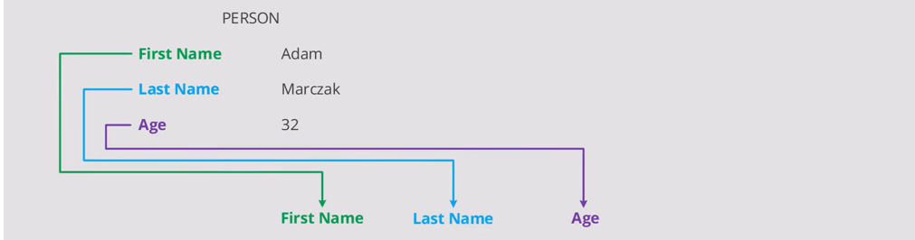

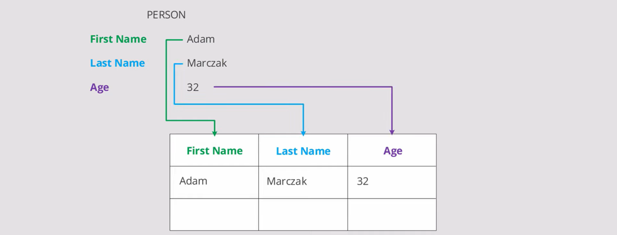

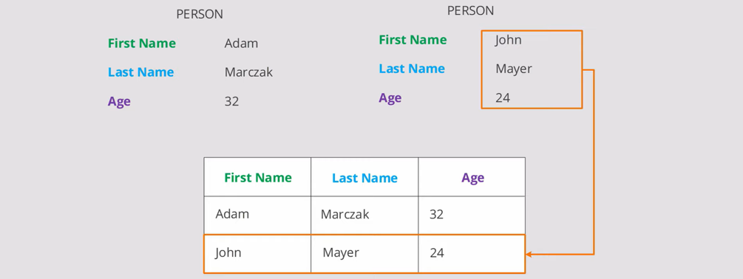



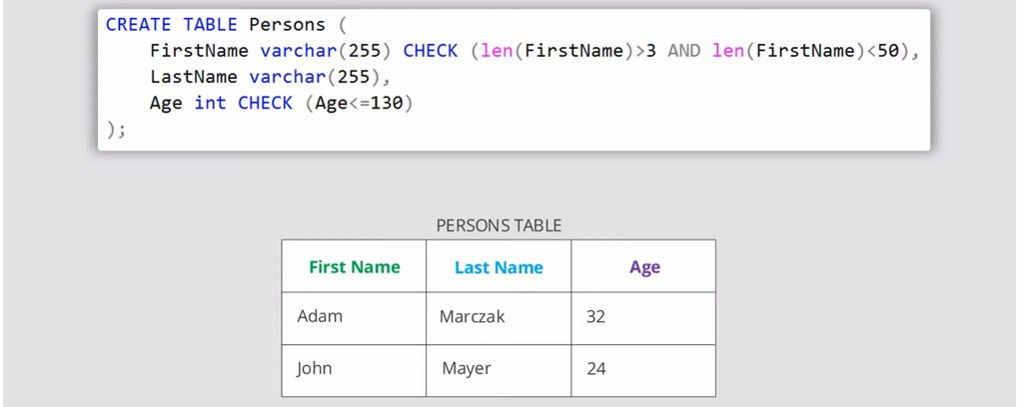

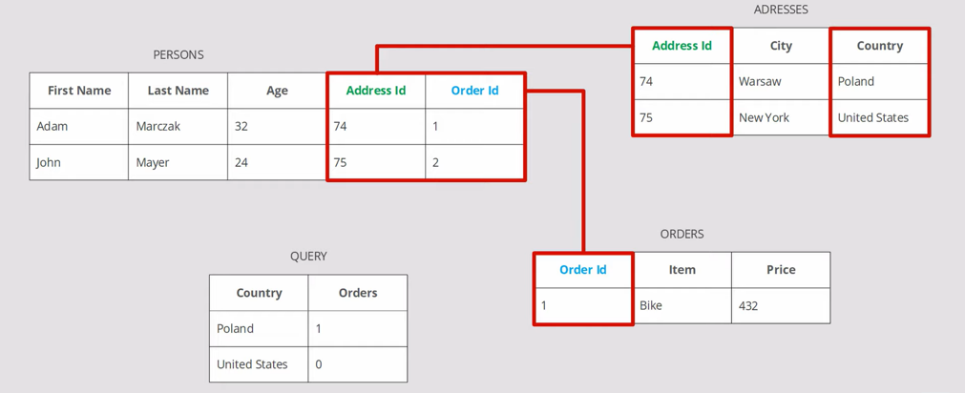



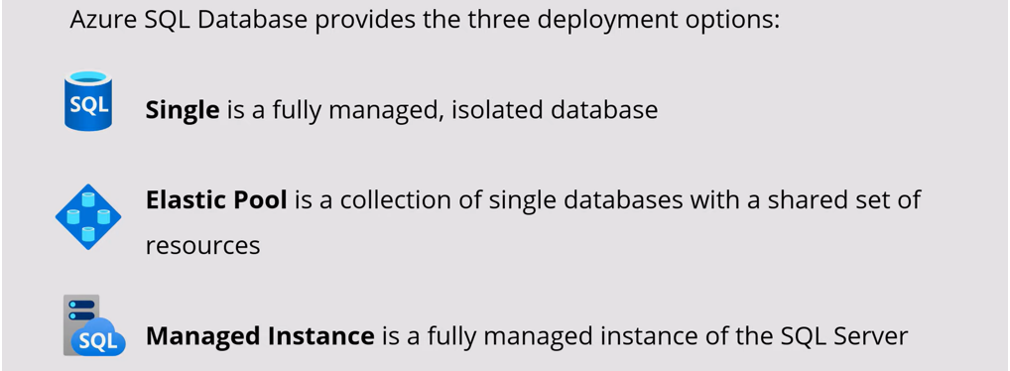

So, one important thing to understand here is when you're going to be creating SQL database in a cloud, you're going to be actually creating two objects. One of them is SQL server database and the second one is SQL database server. So, the server, think of it like a logical unit. It's a central administrative unit where you can manage your single database or pool database. What kind of things like logins, firewall rules, auditing, threat detection, etc. and a single server can contain multiple databases.

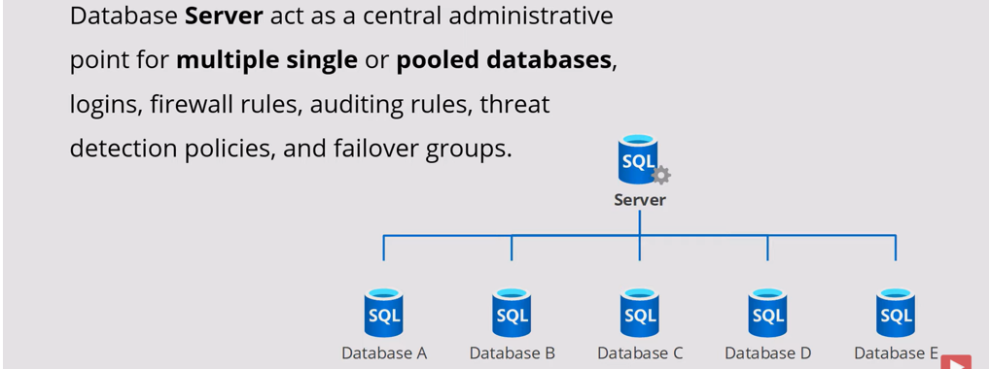

Spring Boot Integration with Azure SQL Database( Deploy Spring Boot CRUD Application to Azure)

let’s demonstrate the database integration with this azure platform.

**App Name**- **springboot-azureSQL**

**Dependencies- Mssql-jdbc, Spring Web, Spring-Data-Jpa, Lombok**

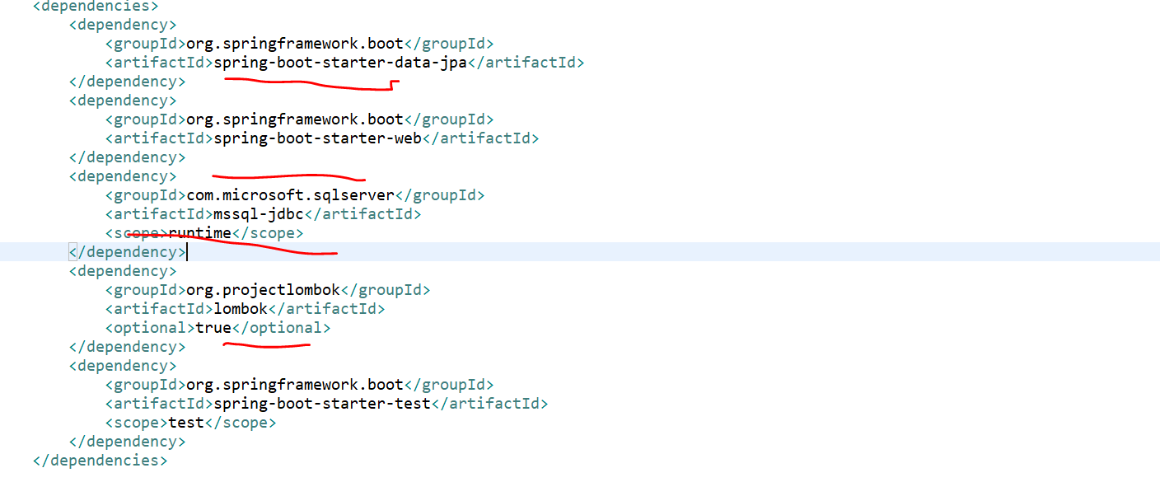

------------------------------------------------------------------------------------------------------------------------------------------

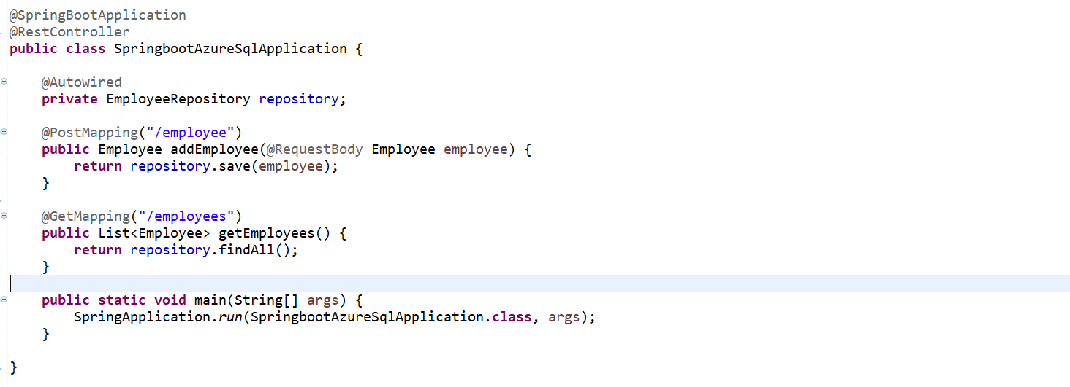------------------------------------------------------------------------------------------------------------------------------------------

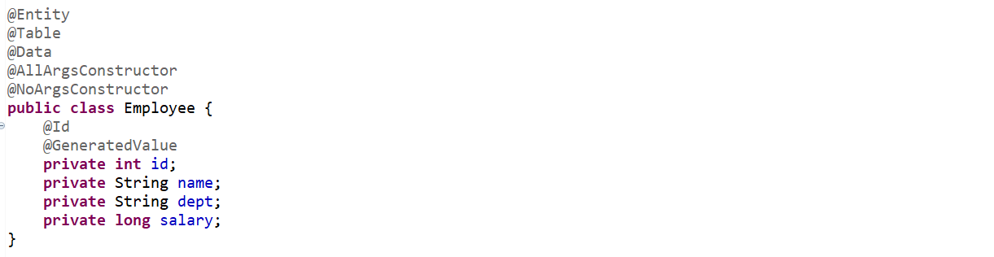

-----------------------------------------------------------------------------------------------------------------------------------------

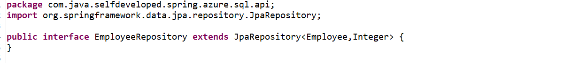

So, we created our controller, we created our repository and we created our entity.

**Now to connect our application to the database we need datasource properties. We are not going to interact with our local machine database. so, we just need to connect to our azure SQL database. so first let’s create the Azure SQL Instance in Microsoft azure portal.**

So, let’s create a file called **application.yml**. I will just add the datasource properties. We don’t know the value of url, username and password. That will get once we will create the Azure SQL Instance,

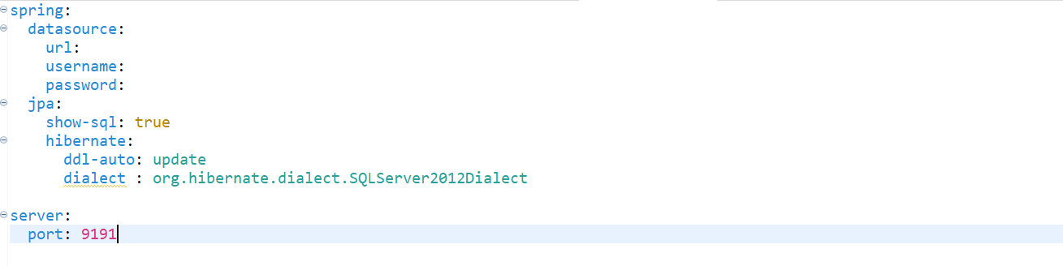

**Azure-> SQL Database**

Create SQL database server Instance

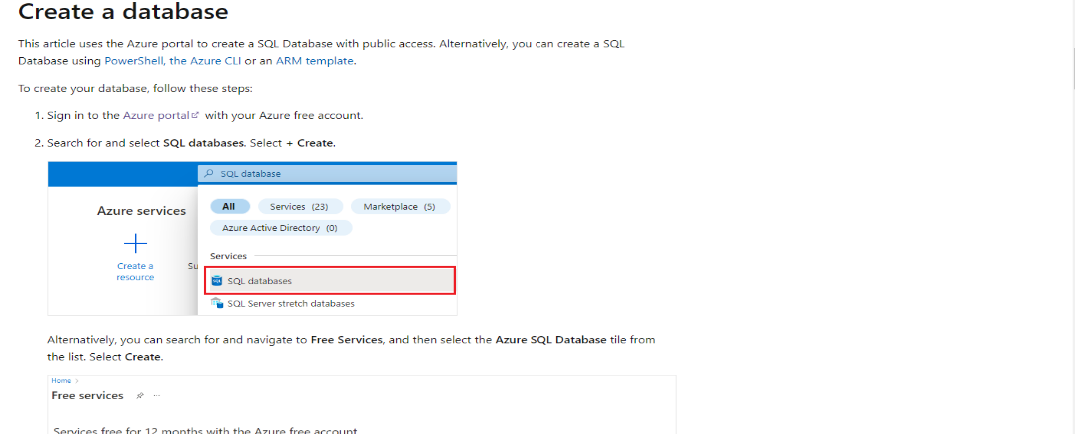

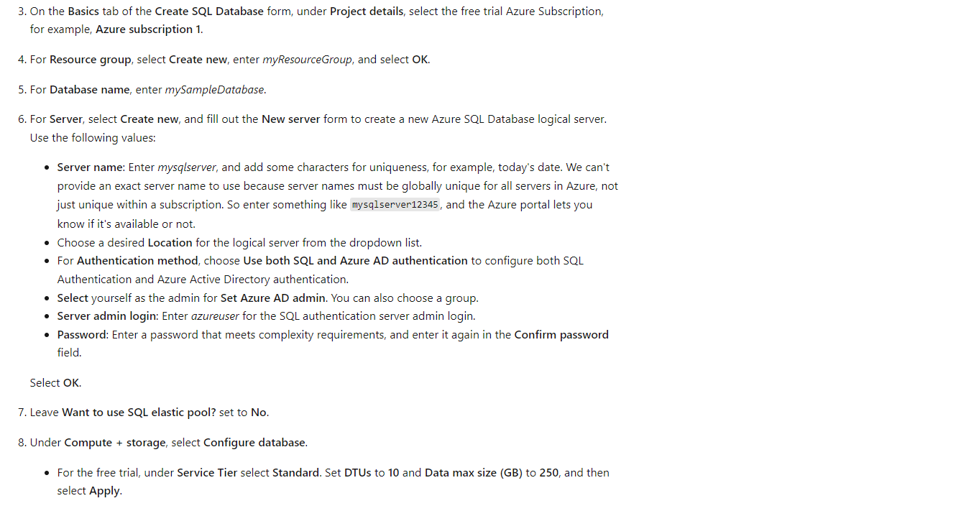

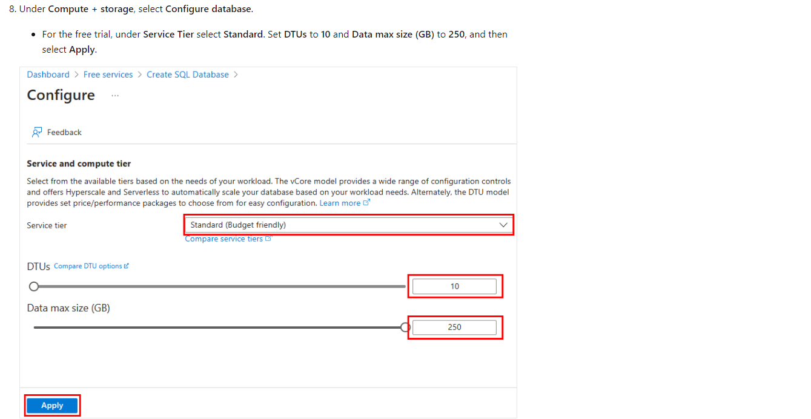

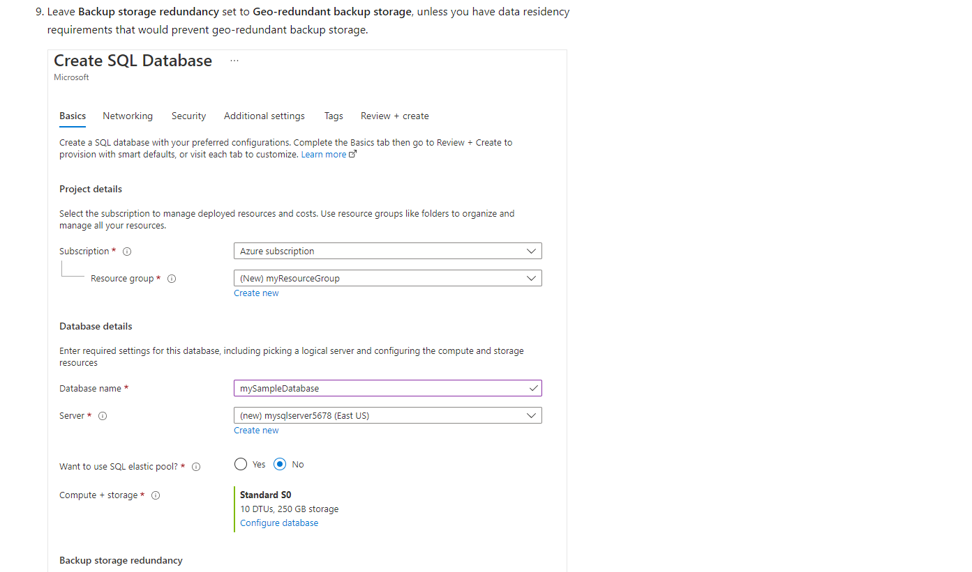

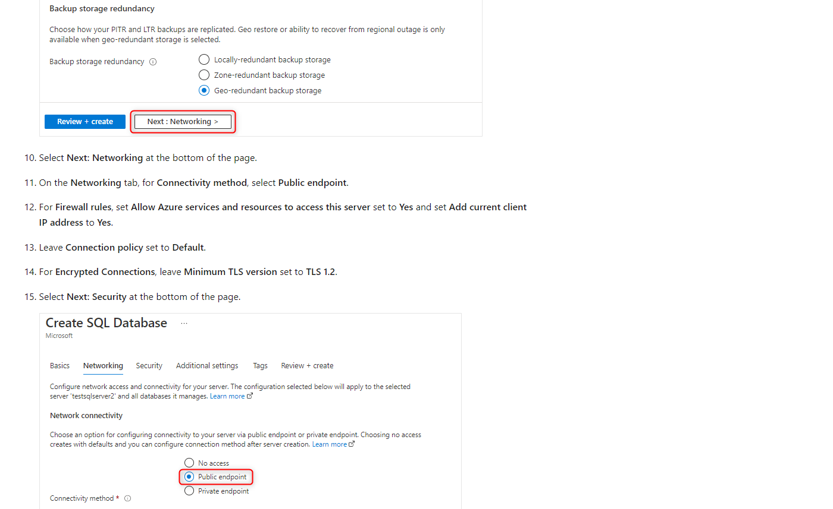

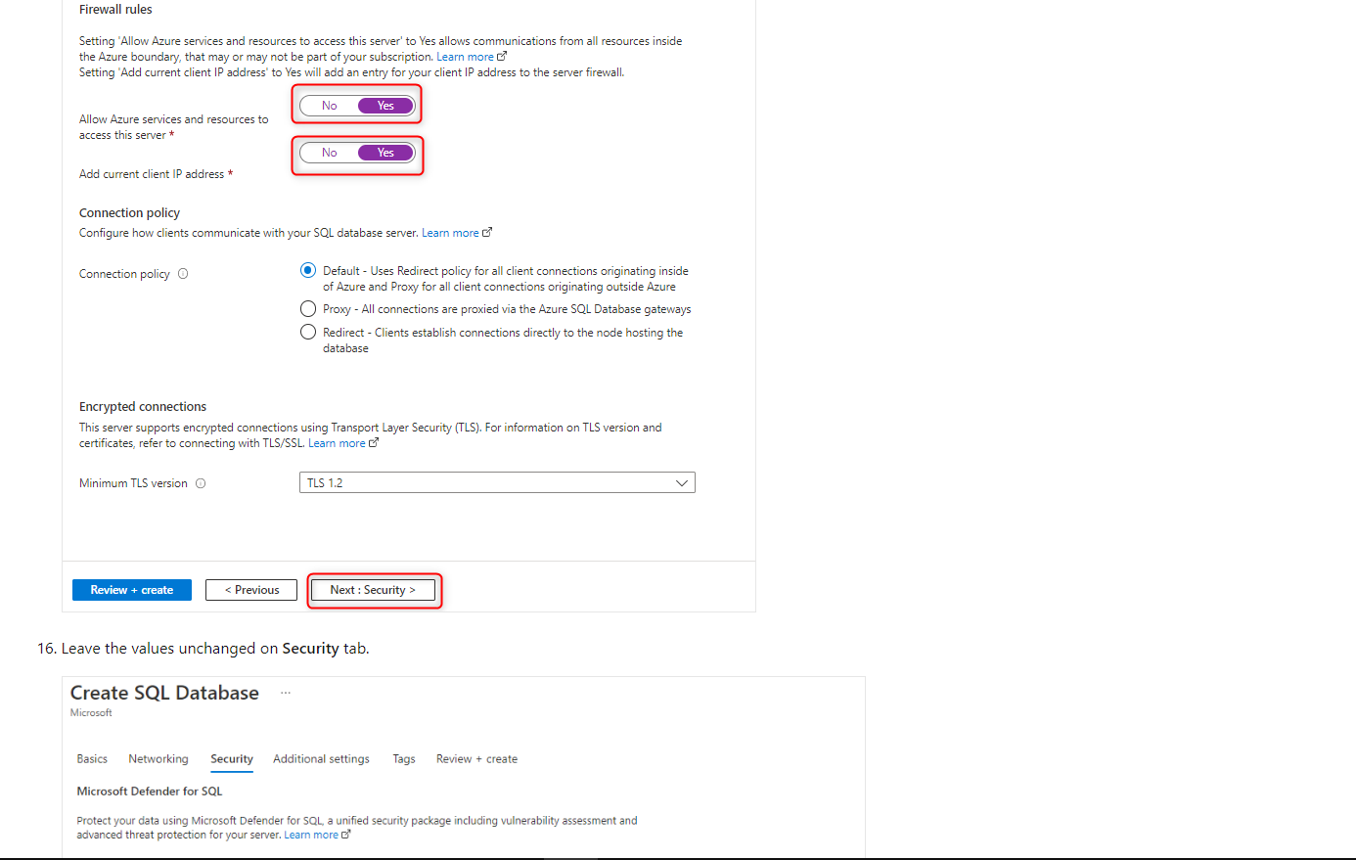

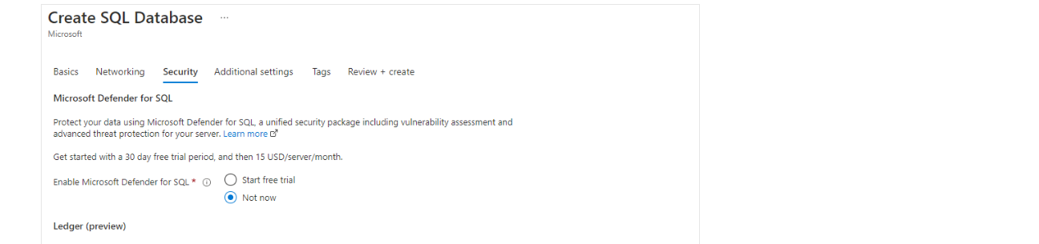

So, this is what the SQL Instance we have created.

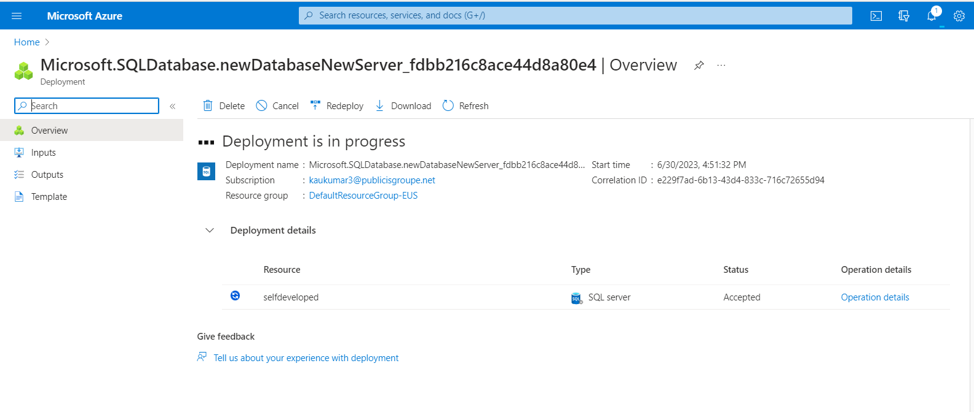

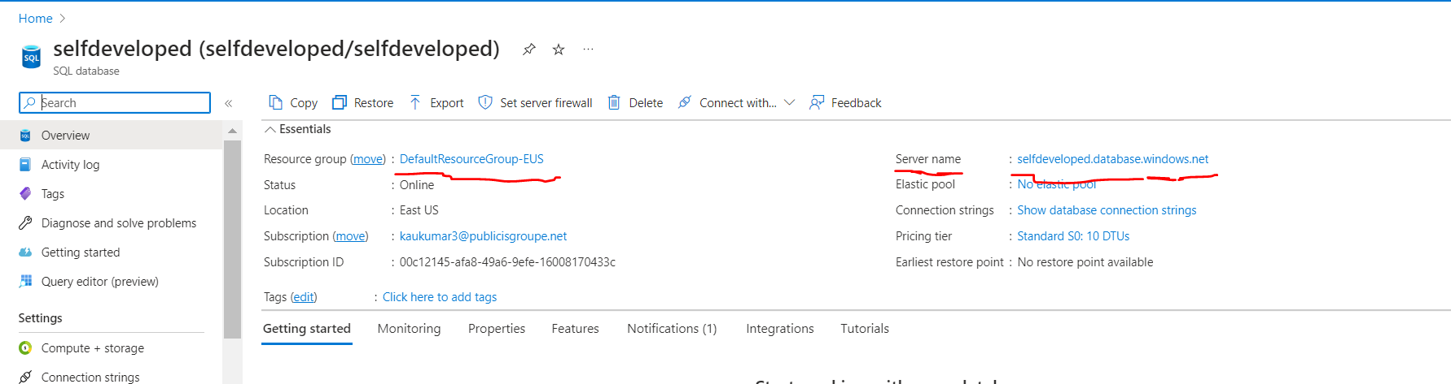

Now let’s click on Connection String and copy the db configuration details

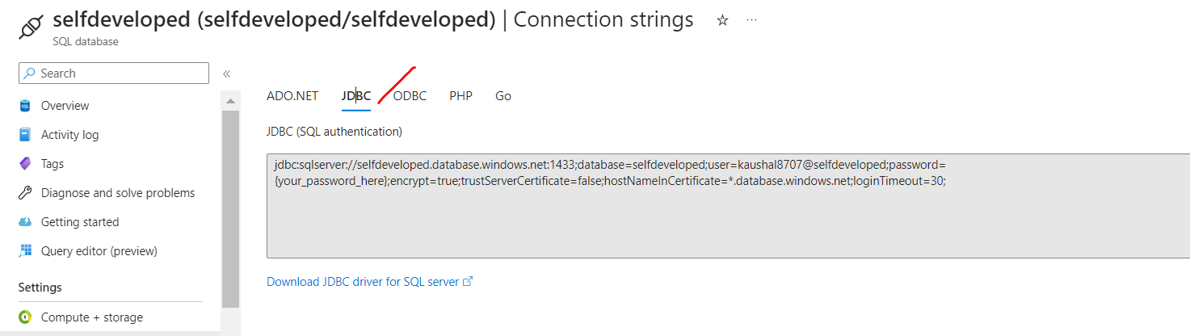



This is copied one but actually we don’t need these database, username, and password detail so let’s remove and just keep url detail



This is **application.yml** file which means datasource file in our application.

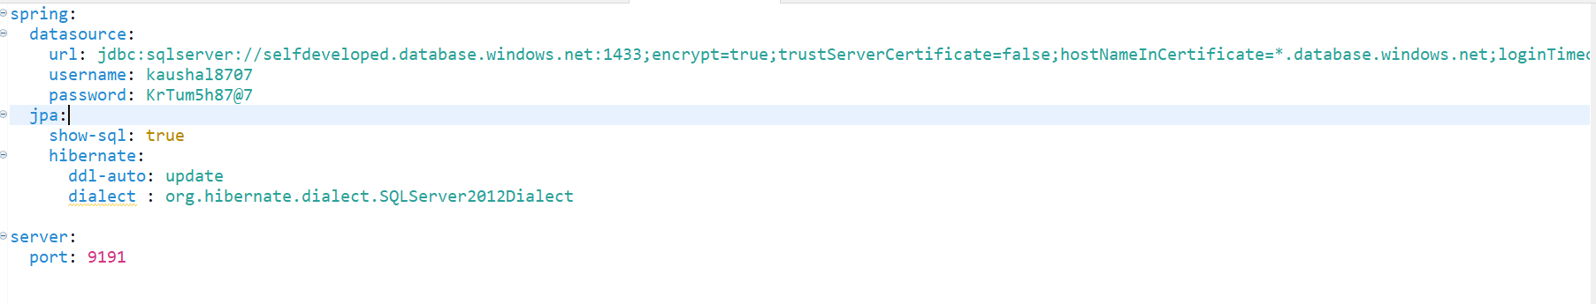

Now go to set server level firewall.

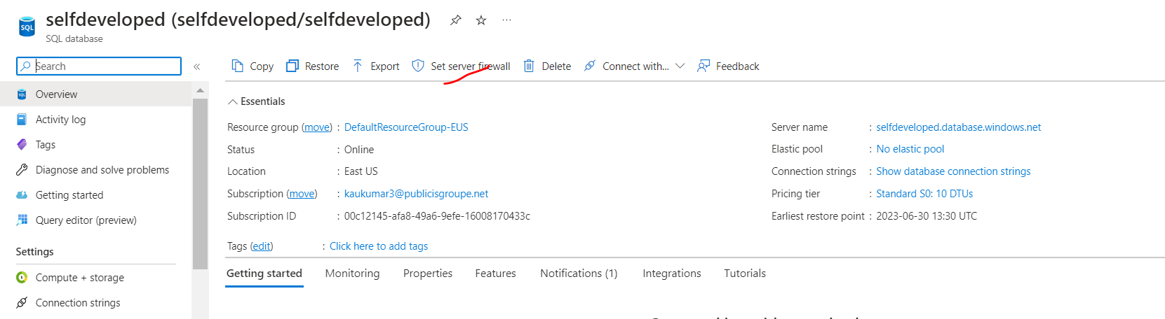

Click on add client Ip and save it.

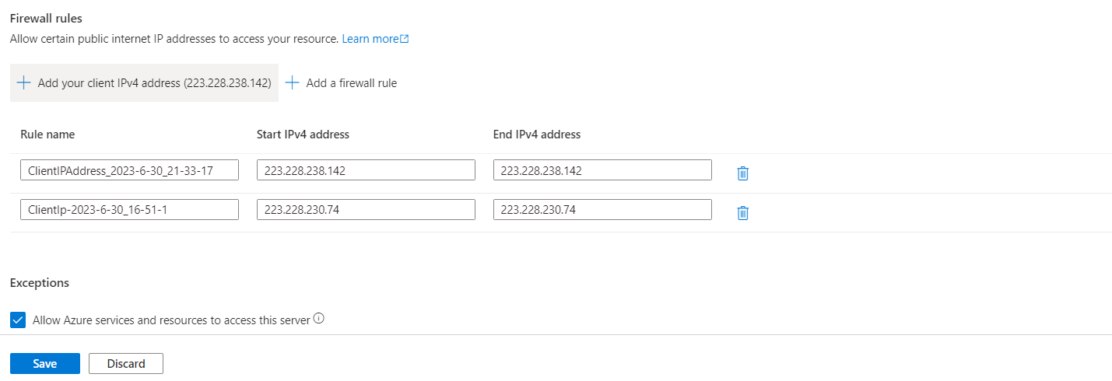

Now there is an option called Query Editor---

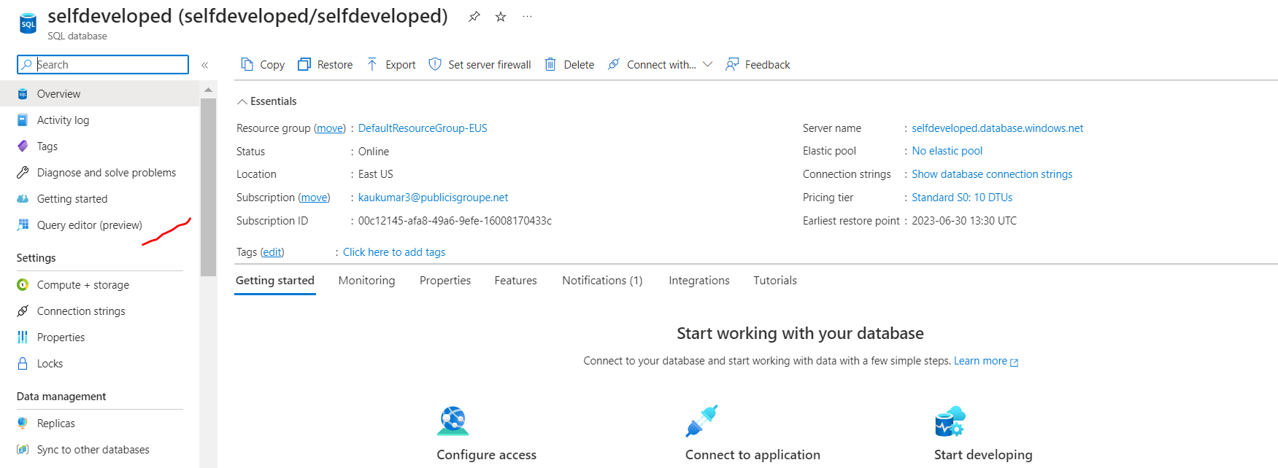

You just need to Login with your password.

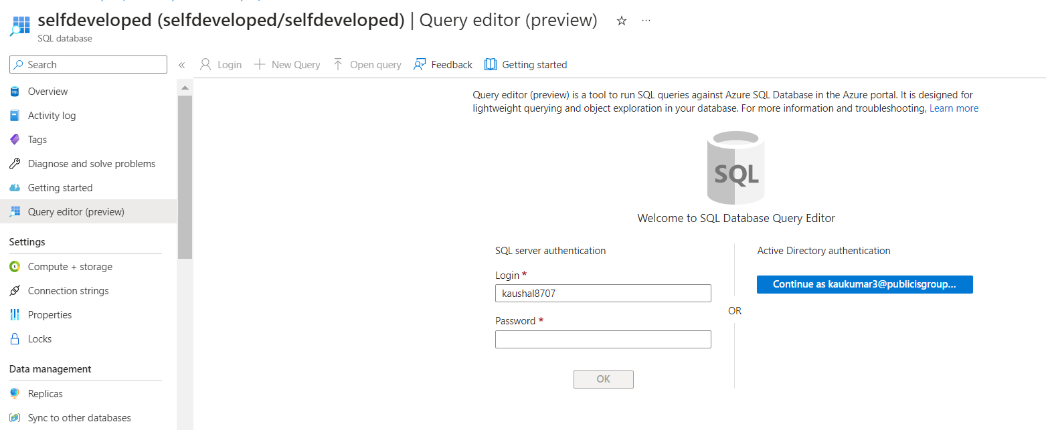

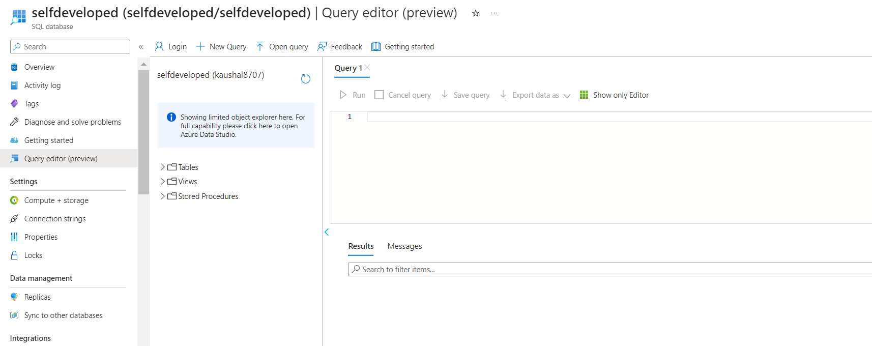

now there are no tables in our azure SQL database. so, let’s start our application in local and it will start on port 9191 and let’s try to hit endpoint and see the database details on our azure database.

<http://localhost:9191/employee>

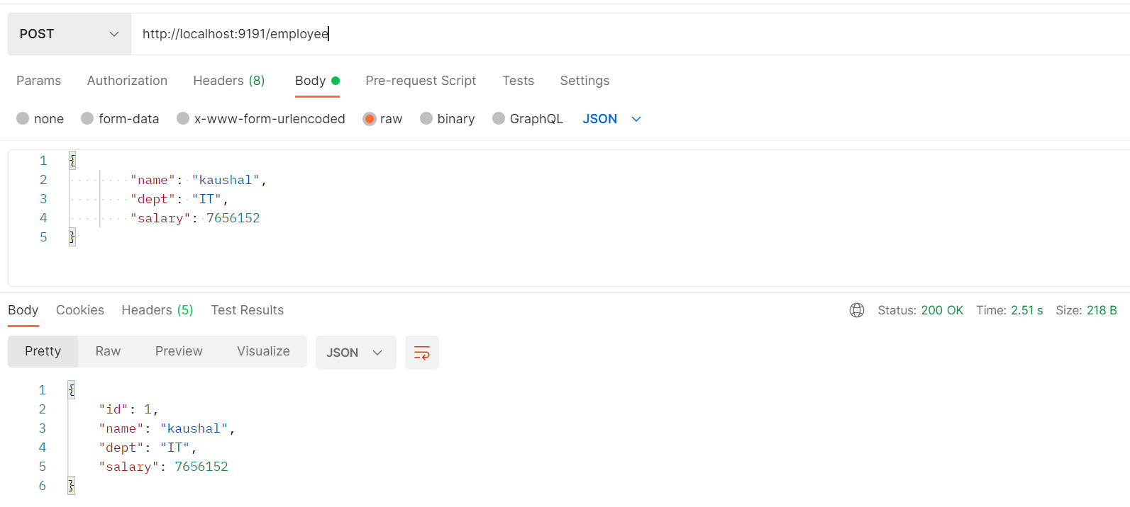

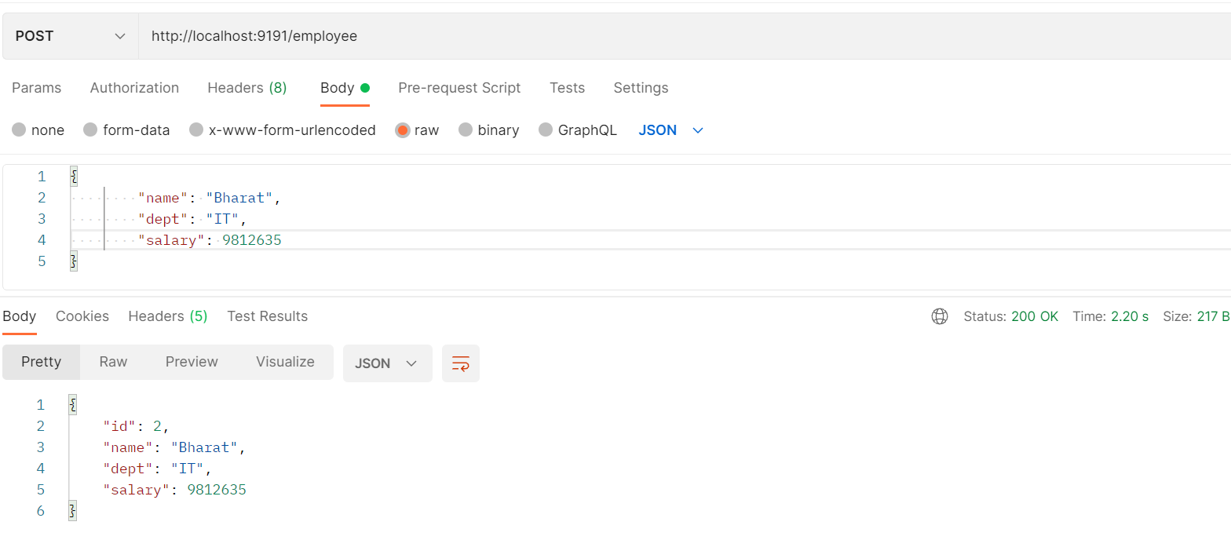

Now go to azure portal and Query Editor and see the database query…

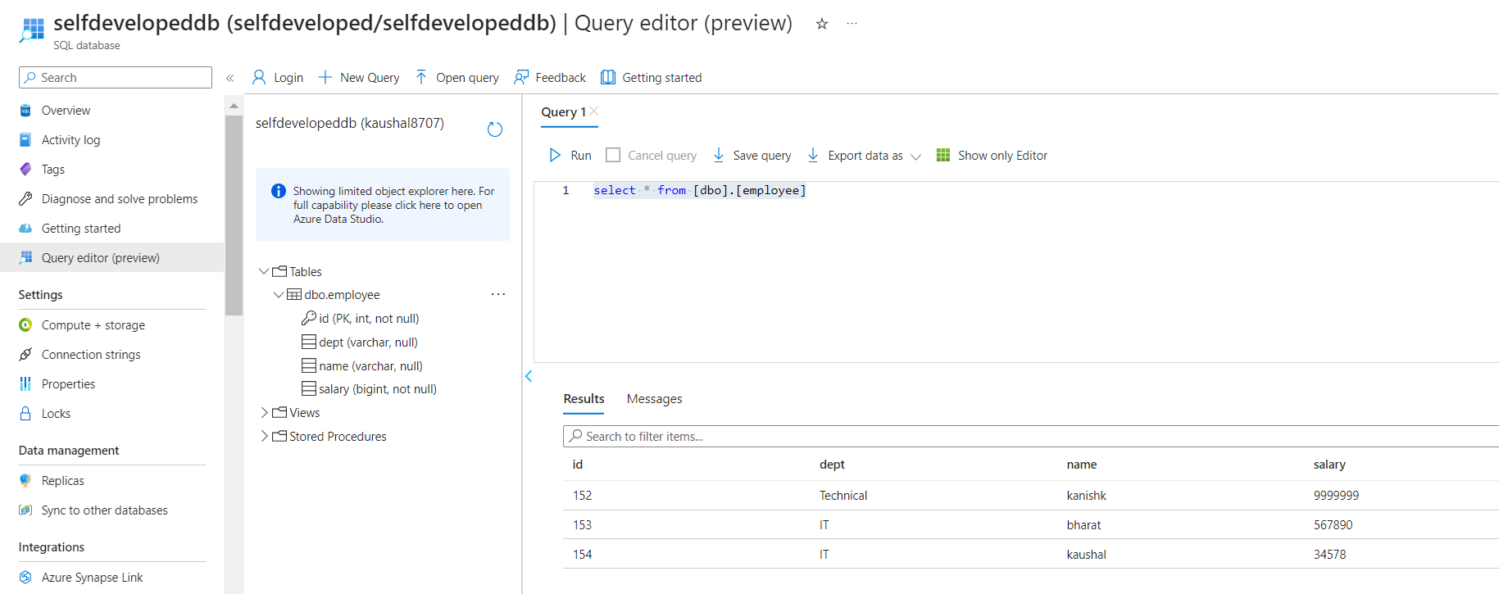

XXXXXXXXXXXXXXXXXXXXXXXXXXXXXXXXXXXXXXXXXXXXXXXXXXXXXXXXXXXXXXXXXXXXXXX

Let me deploy my application to azure cloud so before that let me create a git repo and commit your code.

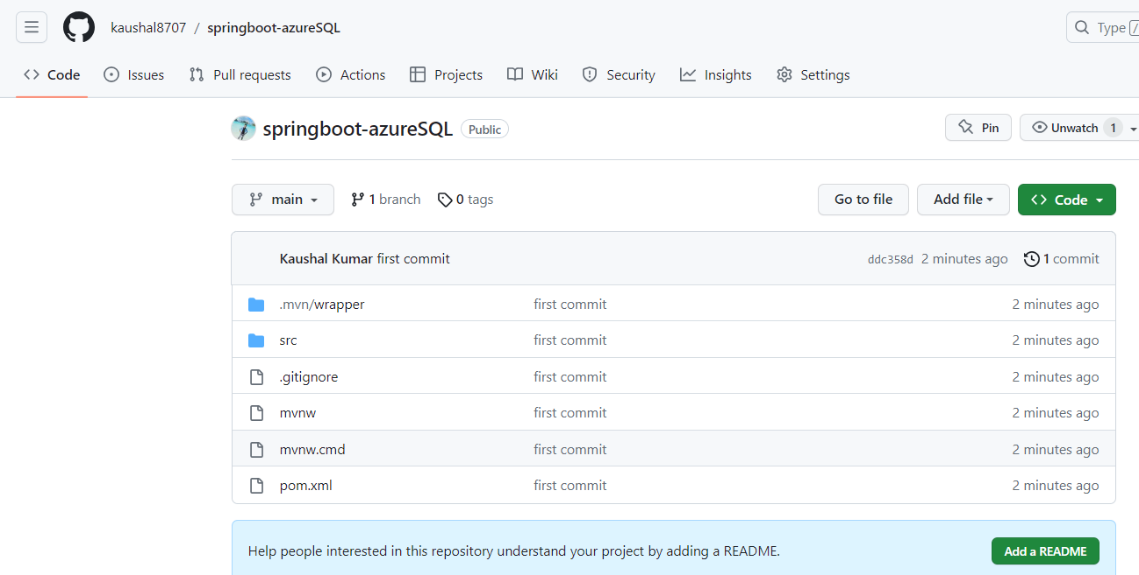

Now let me deploy my spring boot application so let me open another tab and open app service.

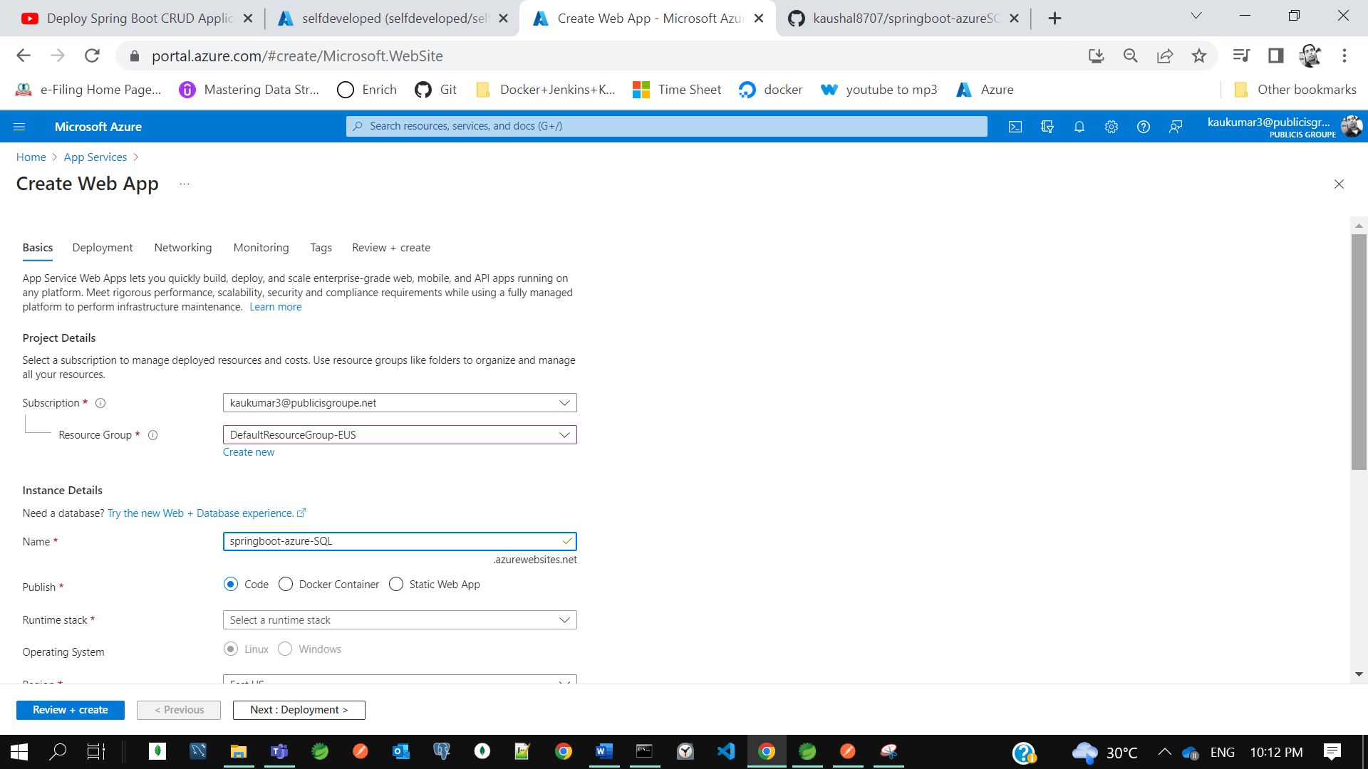

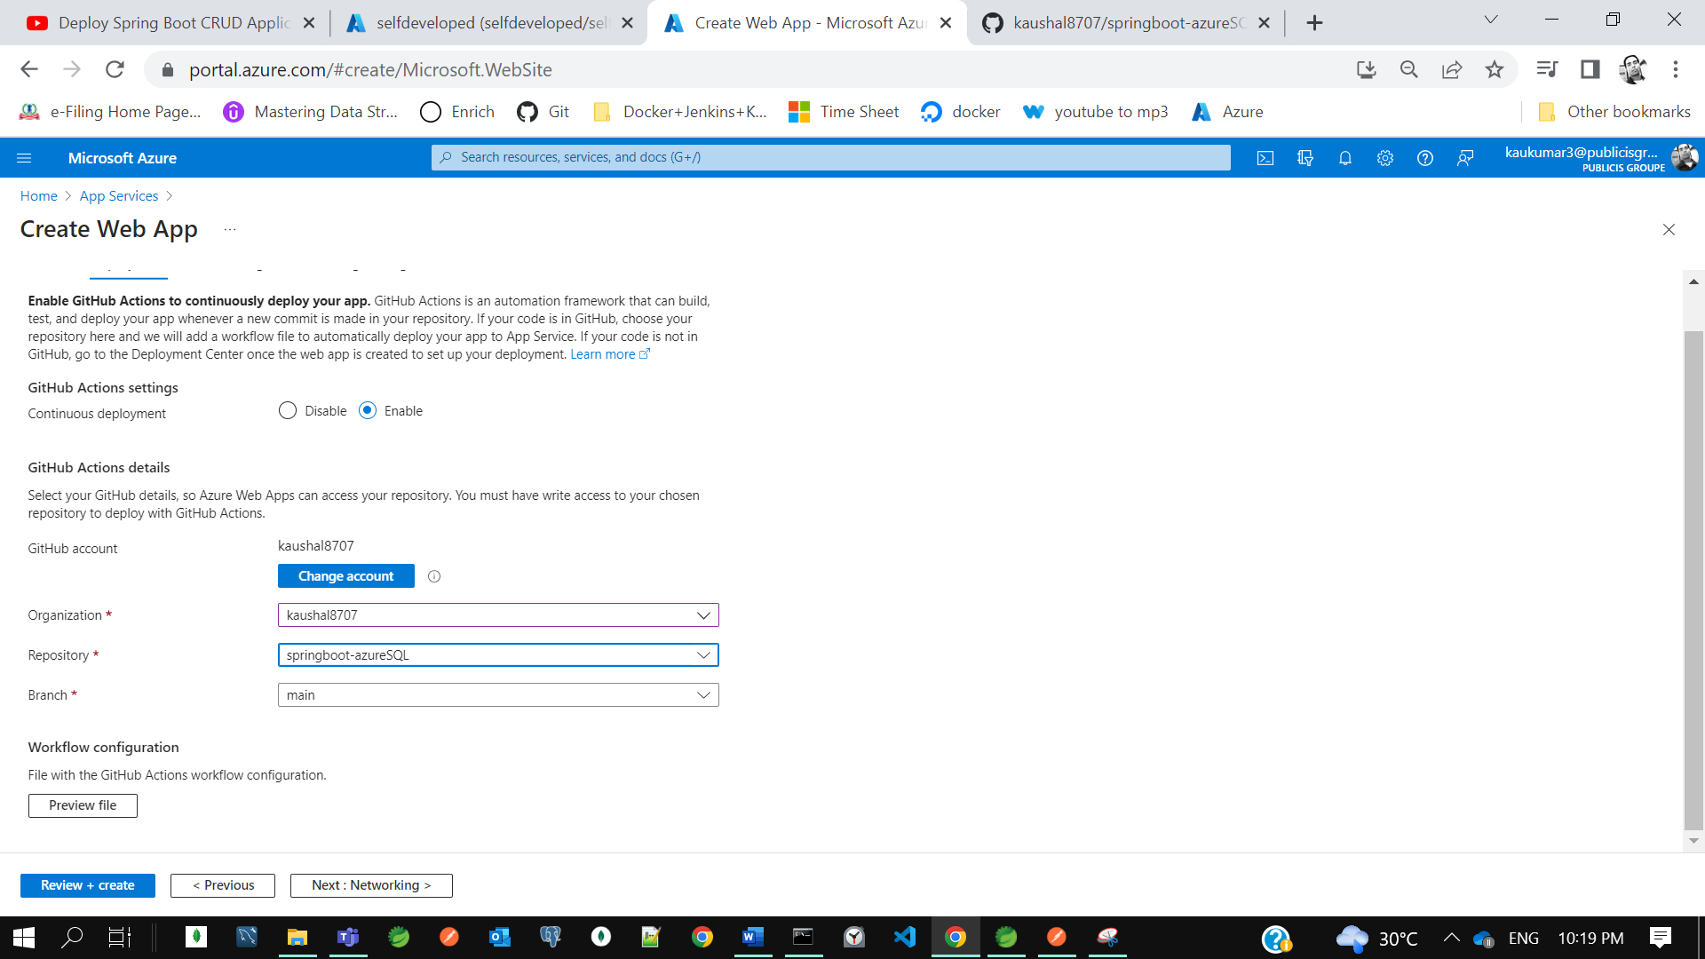

­­­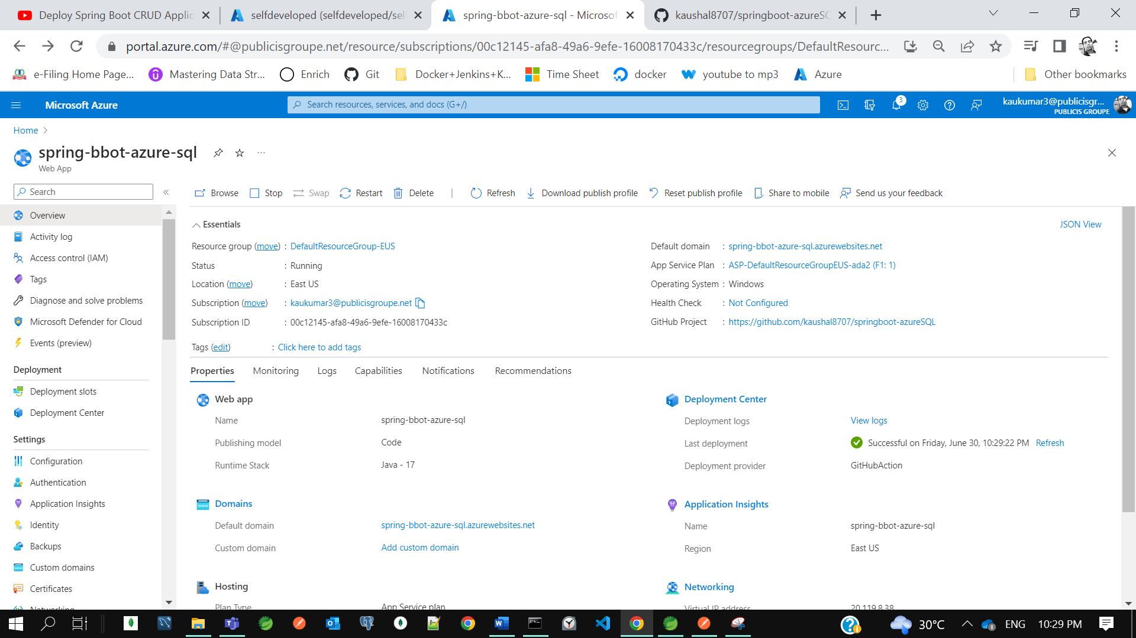

Now got o deployment center

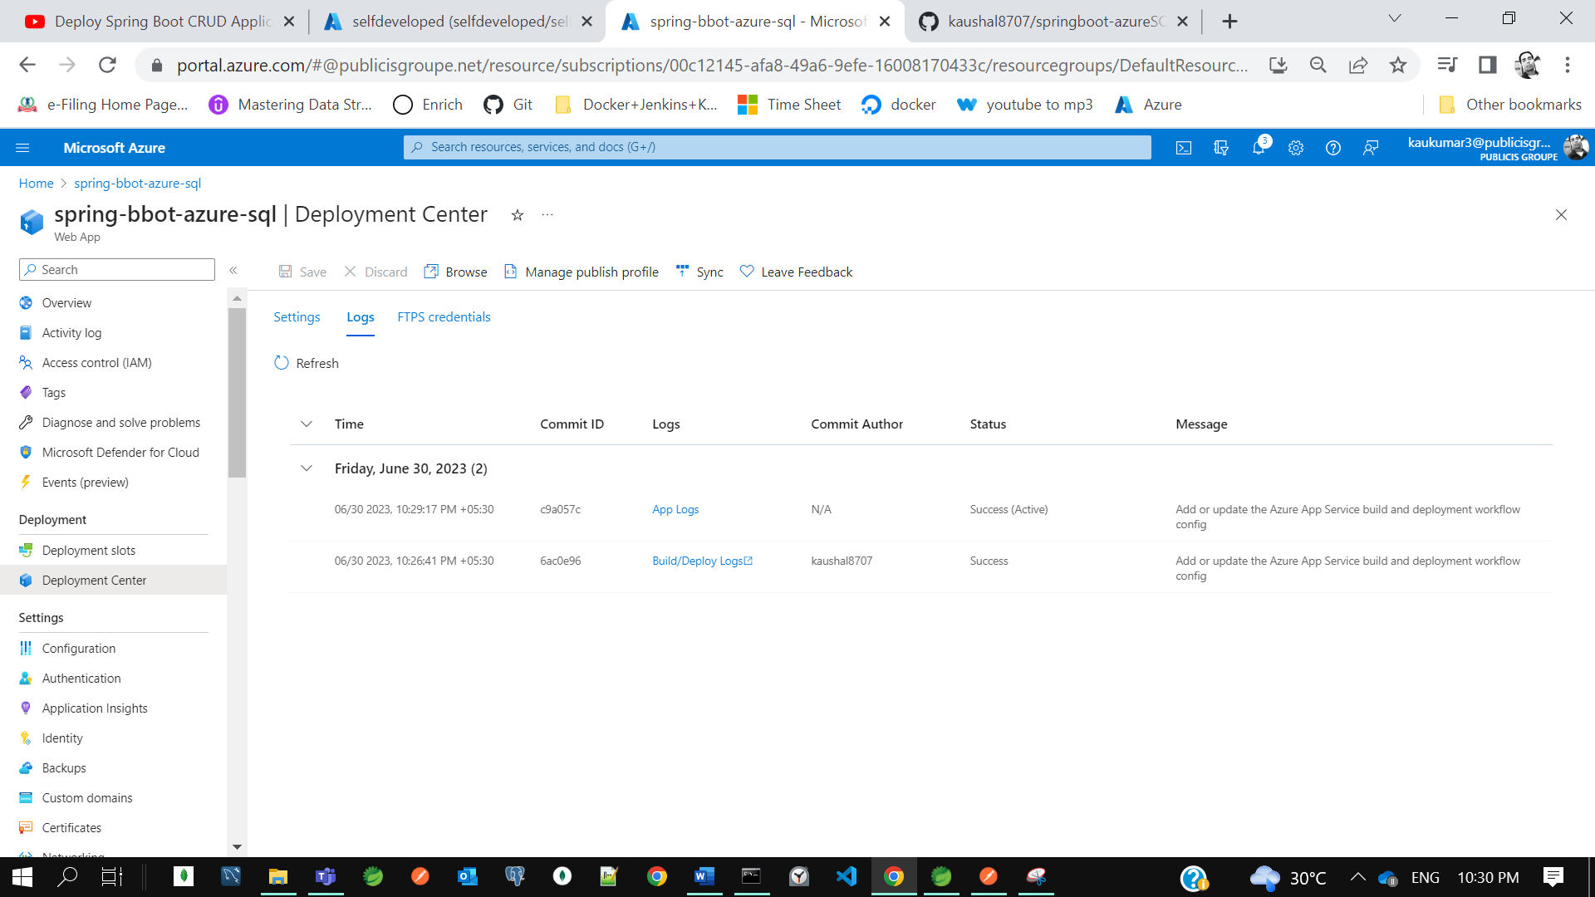

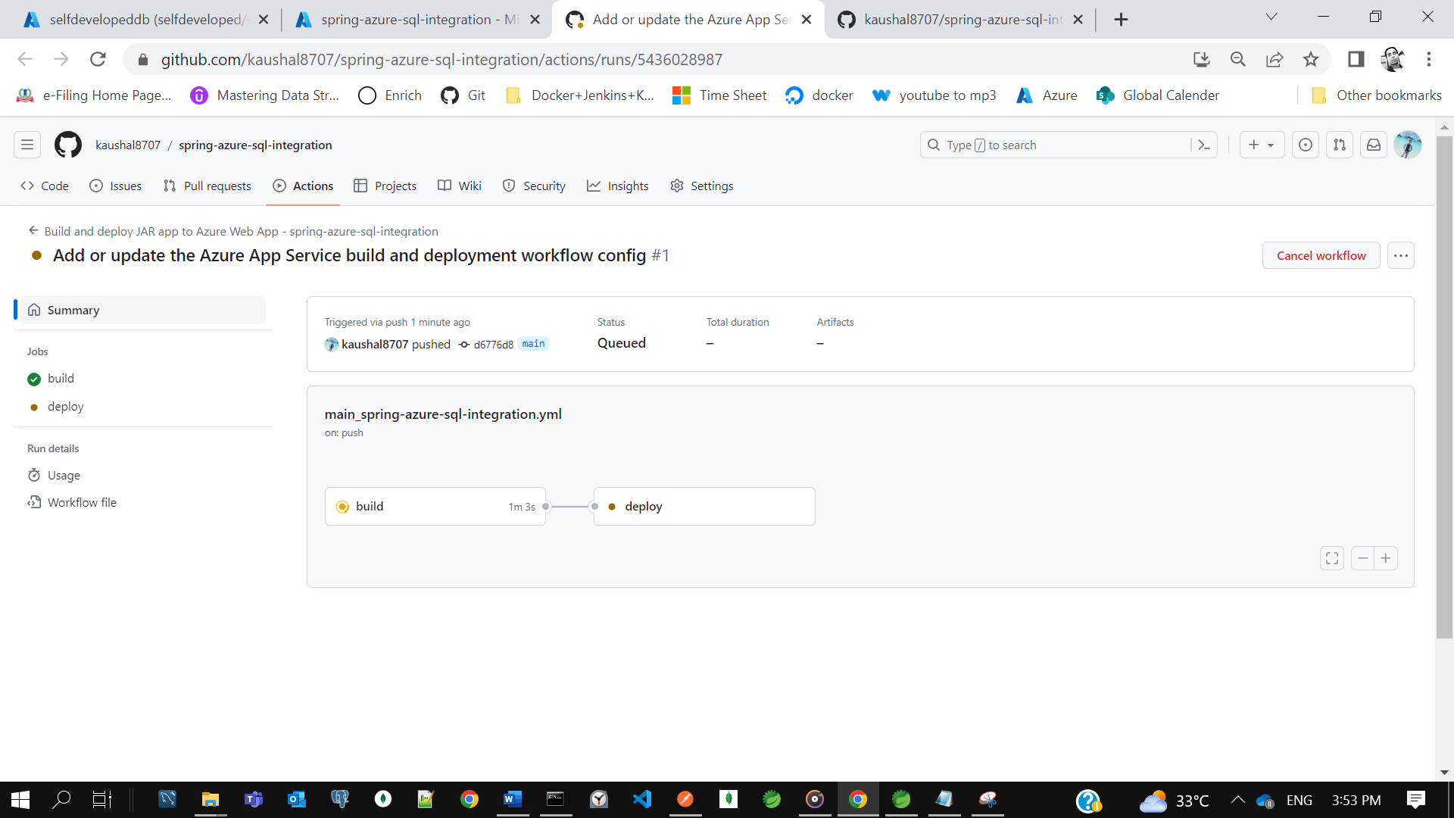

Now our build and deployment both has been done.

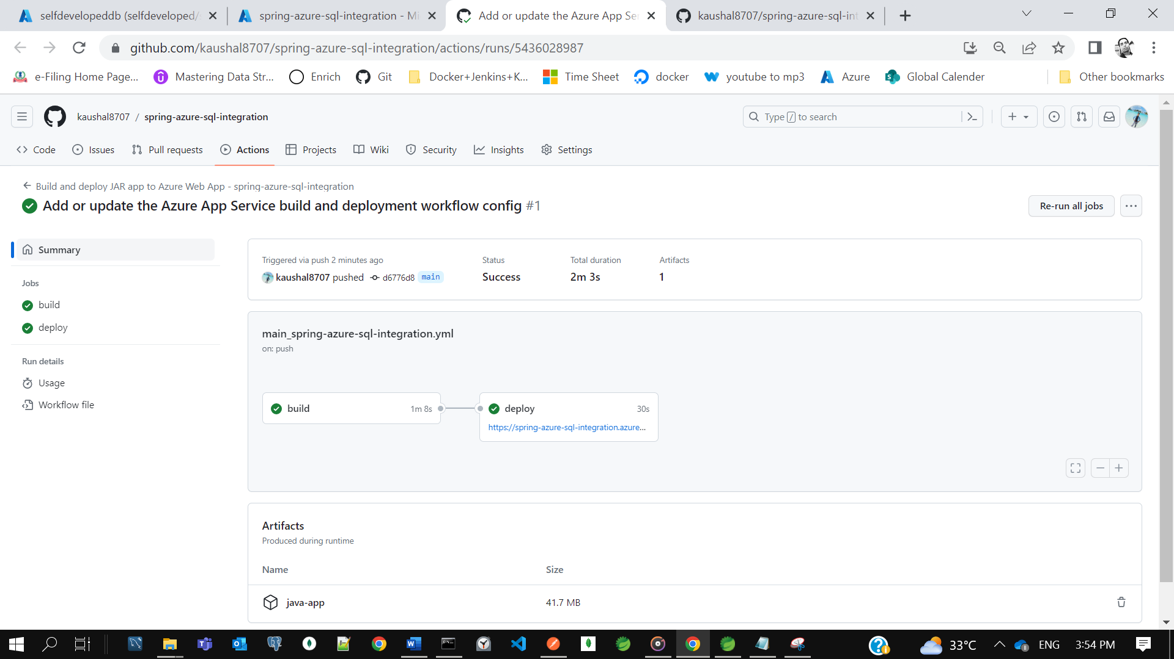

Now our host is

<https://spring-azure-sql-integration.azurewebsites.net/>

now we have hosted our application on cloud

<https://spring-azure-sql-integration.azurewebsites.net/employees>

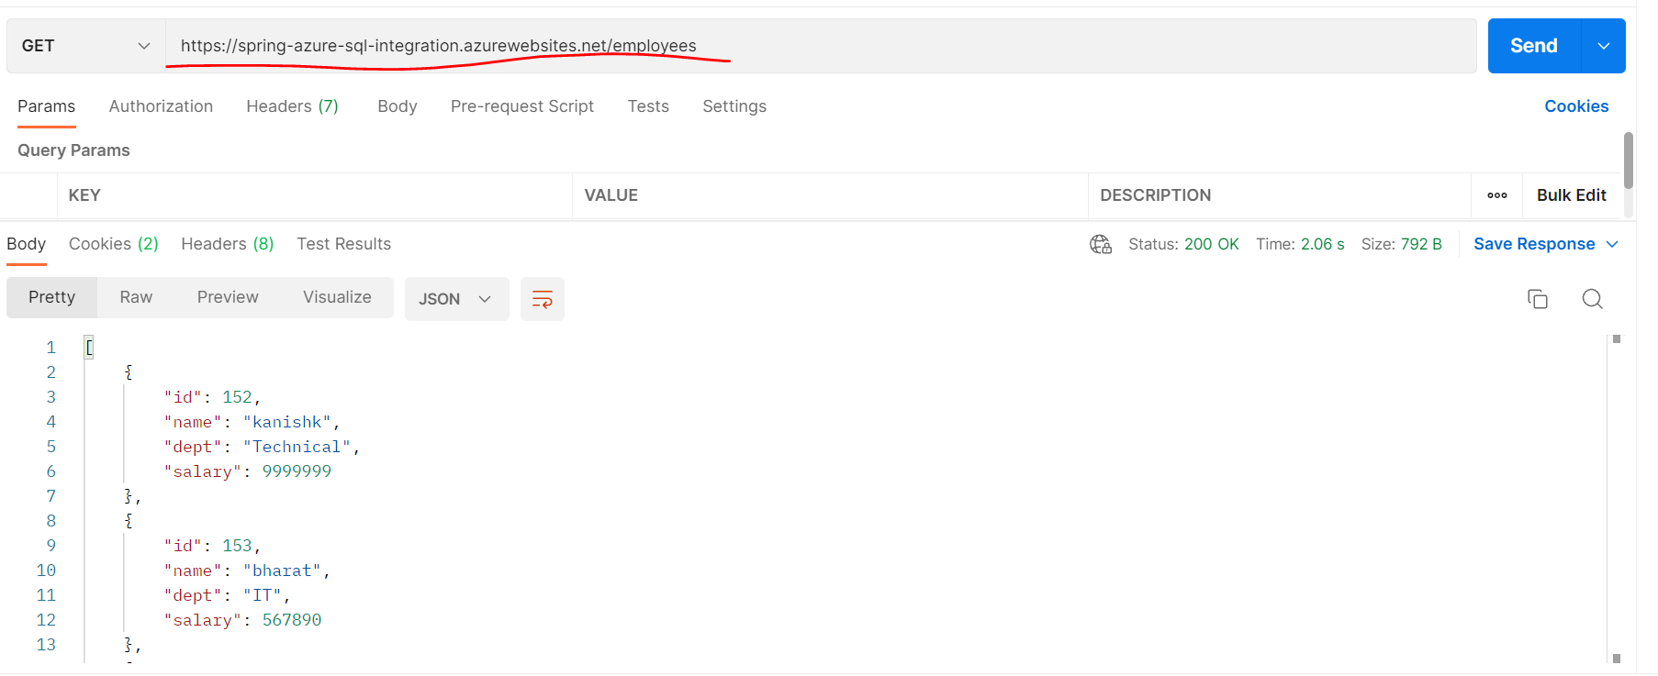

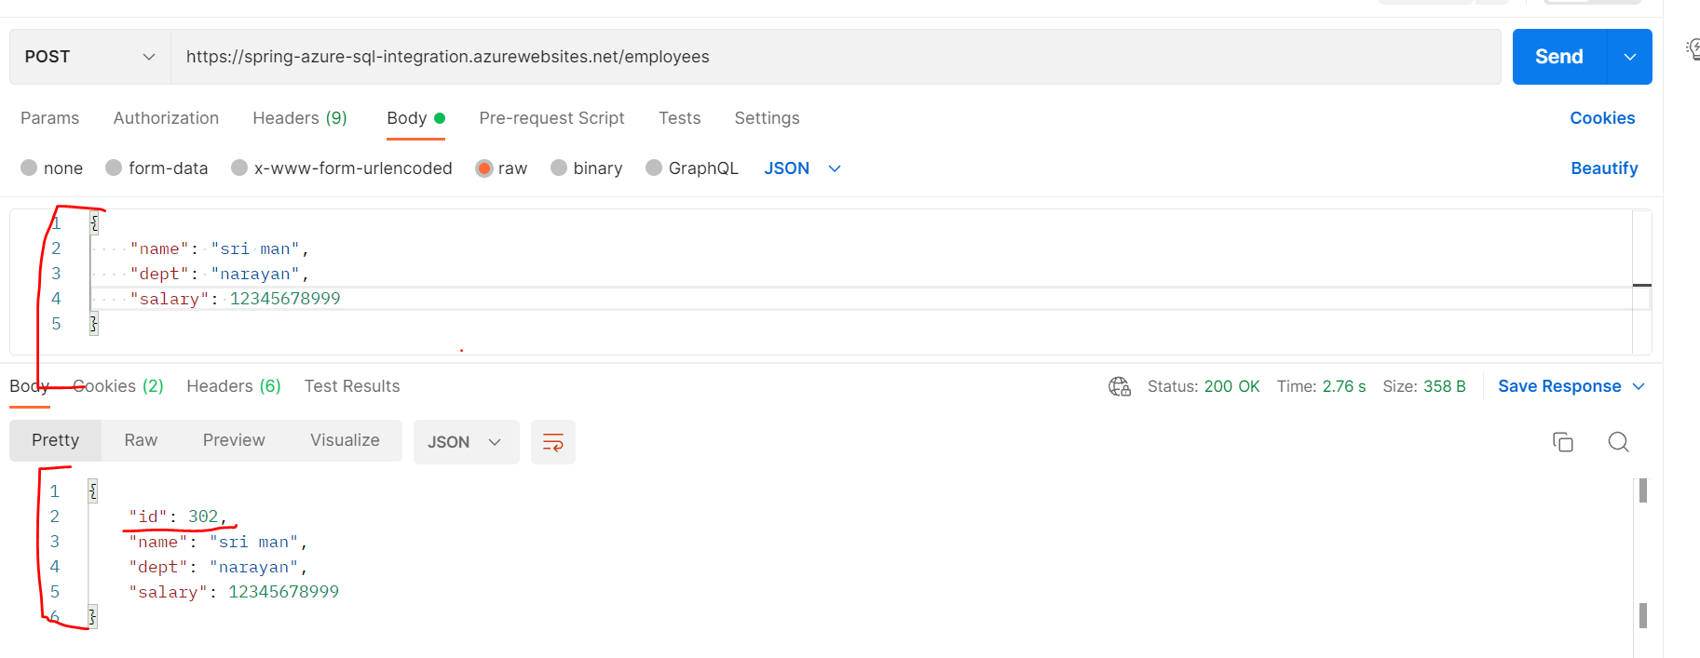

**Important Links:**

[**https://www.youtube.com/watch?v=inaXkN2UrFE&list=PLGjZwEtPN7j-Q59JYso3L4_yoCjj2syrM&index=10**](https://www.youtube.com/watch?v=inaXkN2UrFE&list=PLGjZwEtPN7j-Q59JYso3L4_yoCjj2syrM&index=10)

**Azure Logic App**

<https://www.youtube.com/watch?v=ZvsOzji_8ow>

**Azure App Service(Web Apps)**

<https://www.youtube.com/watch?v=4BwyqmRTrx8>

**Azure Function Apps( Introduction for Serverless programming)**

<https://www.youtube.com/watch?v=Vxf-rOEO1q4>

**Azure Cosmos DB(Globally distributed NoSQL database)**

<https://www.youtube.com/watch?v=R_Fi59j6BMo>

**Azure SQL database(Relational Database in Azure)**

<https://www.youtube.com/watch?v=BgvEOkcR0Wk>

**Azure Event Grid**

<https://www.youtube.com/watch?v=TujzkSxJzIA>

**Azure Container Instances( Serverless containers in cloud)**

<https://www.youtube.com/watch?v=jAWLQFi4USk>

**Azure Storage| Introduction to Blob, Queue, Table & File Share**

<https://www.youtube.com/watch?v=UzTtastcBsk>

**Integration**

**Microsoft AzureSQL**

[**https://www.youtube.com/watch?v=puVMCRvdE9A**](https://www.youtube.com/watch?v=puVMCRvdE9A)

azuresingh263@gmail.com

**Azure In Deep Dive Link-**

**Azure -> https://portal.azure.com/**

**Microsoft Azure Fundamentals (AZ-900)**

[**https://www.youtube.com/watch?v=inaXkN2UrFE&list=PLGjZwEtPN7j-Q59JYso3L4_yoCjj2syrM&index=10**](https://www.youtube.com/watch?v=inaXkN2UrFE&list=PLGjZwEtPN7j-Q59JYso3L4_yoCjj2syrM&index=10)

**Azure Logic Apps**

[**https://www.youtube.com/watch?v=ZvsOzji_8ow&list=PLGjZwEtPN7j_nFYA1qc7cWumNr89PkfAX**](https://www.youtube.com/watch?v=ZvsOzji_8ow&list=PLGjZwEtPN7j_nFYA1qc7cWumNr89PkfAX)

**Azure Storage**

[**https://www.youtube.com/watch?v=UzTtastcBsk&list=PLGjZwEtPN7j9hIHIQJ1Uh6IxEImhWZkPy**](https://www.youtube.com/watch?v=UzTtastcBsk&list=PLGjZwEtPN7j9hIHIQJ1Uh6IxEImhWZkPy)

**Azure Storage Account**

[**https://www.youtube.com/watch?v=UzTtastcBsk&list=PLGjZwEtPN7j9hIHIQJ1Uh6IxEImhWZkPy**](https://www.youtube.com/watch?v=UzTtastcBsk&list=PLGjZwEtPN7j9hIHIQJ1Uh6IxEImhWZkPy)

# Group coordinator | Group leader | Rebalance Internals | Apache Kafka Tutorial in Hindi | Video 12

<https://www.youtube.com/watch?v=n5kxkFNTZZ0>

# Consumer group in kafka | consumer group rebalancing | Apache Kafka Tutorial in Hindi | Video 11

<https://www.youtube.com/watch?v=zVSaT0glaX8>